List all Part Number and/or Components Required:
Part Number | Description
23169 | CleanView Display Model
1614760 | Kraft Carton
1633180 | Green Backstock Label
1633181 | DPCI Label
1633187 | UPC STICKER

Instructions:
- Pull 23169 unit from inventory.

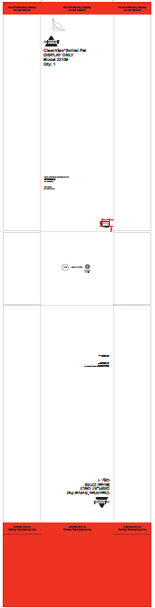

- Open box. Pull unit out. Place UPC Sticker (below), 1633187, sticker on the back of unit.
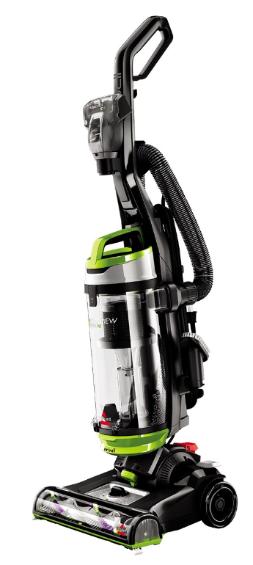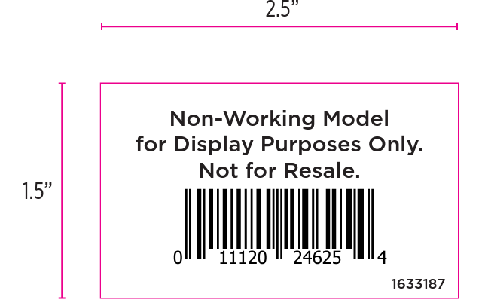

- Repack unit and tape box closed.

- Place 4 of the 1633180 labels on the carton (1 on each side panel). Can go anywhere on the carton as long as it’s not covering anything up or on the top/bottom panel.
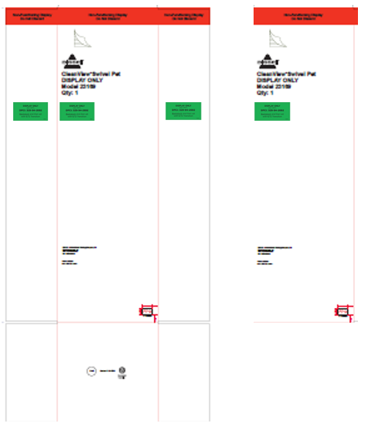
- Place 4 of the 1633181 labels on the carton (1 on each side). Can go anywhere on the carton as long as it’s not covering anything up or on the top/bottom panel.

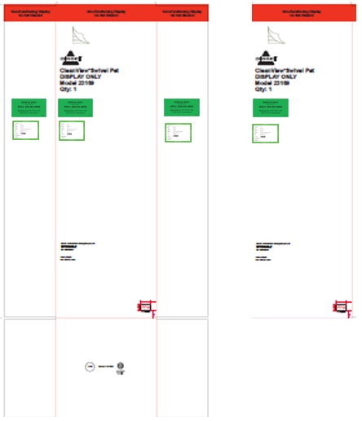

- When completed, the carton should have 4 green backstock stickers and 4 DPCI carton stickers total applied like below.

- Repalletize according to 23169 Pallet Diagram on Supplier Site

