List all Part Numbers and/or Components Required:
Part Number | Description
1635365 | Non-Working unit Kraft Carton - 3834
1644506 | UPC Barcode
1644508 | DPCI Label
1644507 | Backstock label
N/A | Packing tape

Instructions:

- Take one unit of 3834 (carton number 1635365). Remove the unit from the box but keep all packaging materials.

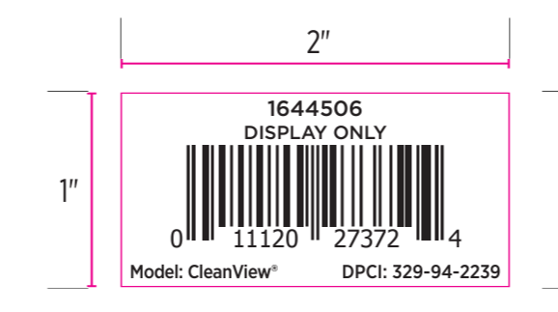
- Add a NWD sticker (1644506) on the back of the unit. Make it visible, without covering any other graphics or stickers.
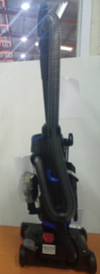

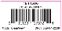

- Place unit back into original kraft carton (1635365) and tape closed.

- Add a Label (1644508) to all six sides (one on each side). Do not cover any writing on the carton.
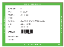
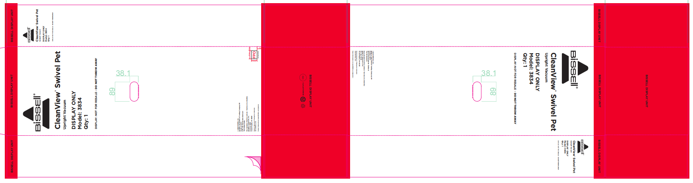

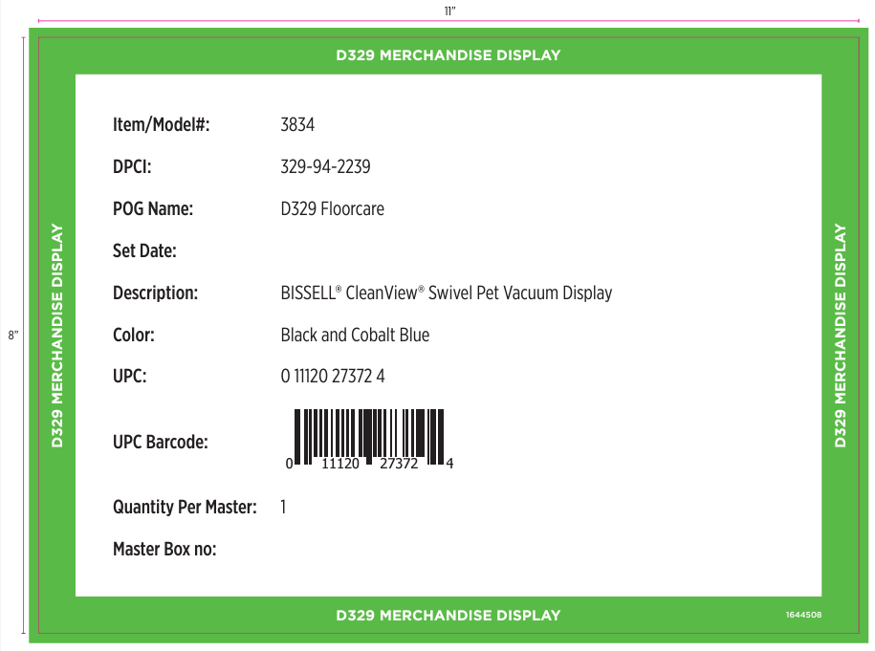

- Add a Label (1644507) to one side. Do not cover any writing on the carton.
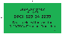

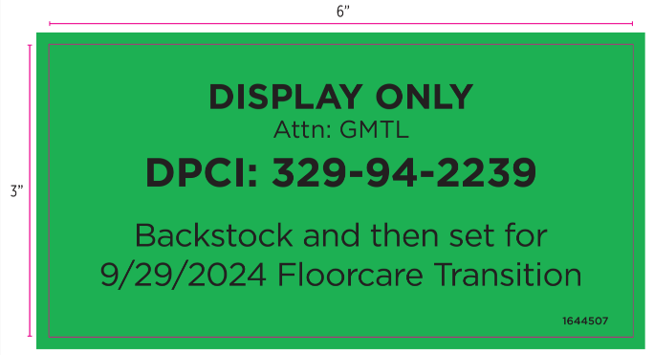

- Repalletize the unit in accordance with 3834 pallet requirements.

