List all Part Number and/or Components Required:
Part Number | Description
1644514 | Yellow – Reset Label
None | Reset Tape
None | Blue – Q2 Sticker

Instructions:

- Pull one unit of 3743 out of inventory.

- Apply the Reset Tape the full length and full width of the carton

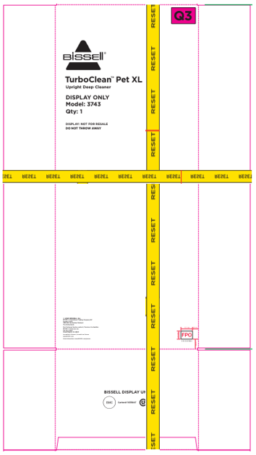

- Take two Yellow – Reset Label (1644514) and add these labels to two different areas. One on the front panel and the other on the top of the carton. Do not cover the Reset tape or any text information on the carton. See below:

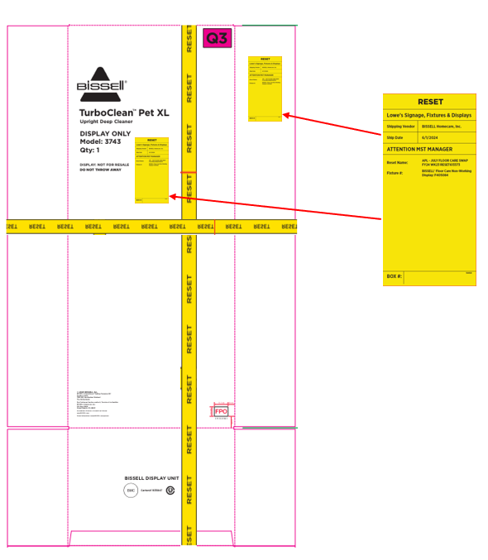

- Take two Blue – Q2 stickers and place over top the pink Q3 that is in the right corner on two sides. One on the front panel and the other on the back panel. See below:

