List all Part Number and/or Components Required:
Part Number | Description
1644527 | Yellow – Reset Label
none | Reset Tape

Instructions:

- Pull one unit of 3716 out of inventory.

- Apply the Reset Tape the full length of the carton and the full width of the carton. It should wrap around the entire carton.

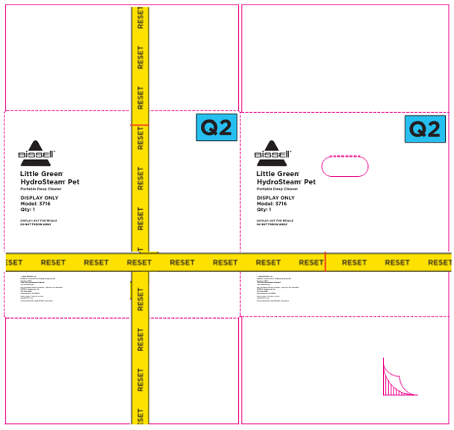

- Take two Yellow – Reset Label (1644527) and add these labels to two different areas. One on the front panel and the other on a side panel of the carton. Do not cover the Reset tape or any text information on the carton. See below:

