List all Part Number and/or Components Required:
Part Number | Description
1642747 | DPCI Sticker (TARG Only)
1643843 | Green Backstock Label

Instructions:
· Label / Parts Ordering will be ordered through Grandville Printing – Tracking will be provided
· Distribution Center & Quantity Needed: See below

DC: Richmond, VA
Qty: 5
Completion Date: Must Ship By 4/28!
Drop Dead Date: 5/6

- Pick up the non-working model: [#3498] and place it on the ground.
- Check package contents to ensure display looks like the following ( See Image Below)

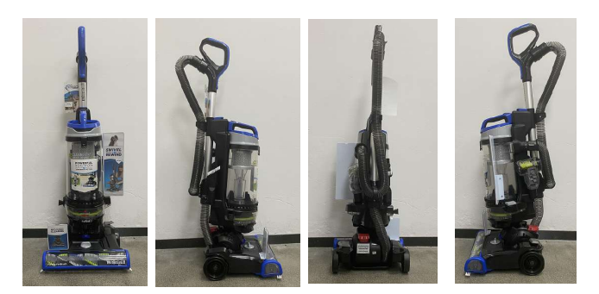

- Add DPCI sticker [1642747] and Green Backstock Label (1643843) to outer carton

- a. DPCI sticker and Green Backstock Label must applied to all 6 sides [all side top & bottom] to the carton.
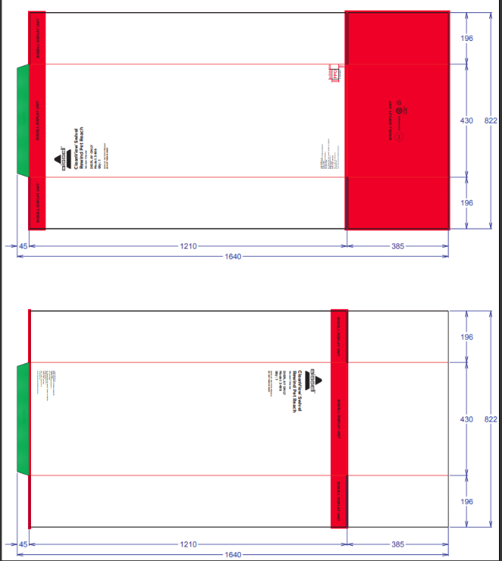
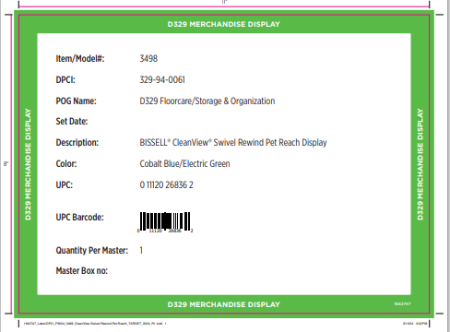
FPO

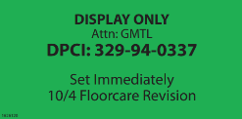
FPO

8. Repalletize based on non-working model configuration for 3498.

