List all Part Numbers and/or Components Required:
Part Number | Description
3418 | SurfaceSense Lift-Off
1628633 | SurfaceSense Lift-Off Kraft Carton
1625325 | Amazon Transparency Label

Instructions:

- Take one unit of SurfaceSense Lift-Off from the pallet. Kraft carton (1628633)

- Locate the barcode on the bottom right-hand corner of the carton.

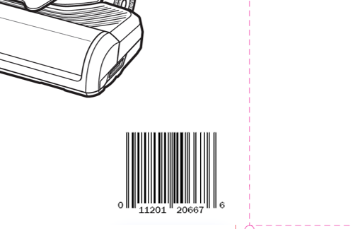
- Place one Amazon Transparency label (1625325) just above the barcode and cover the existing transparency label. Make sure to not cover the barcode or wrap the label around the edge of the box. It must lay flat and completely cover the old label.
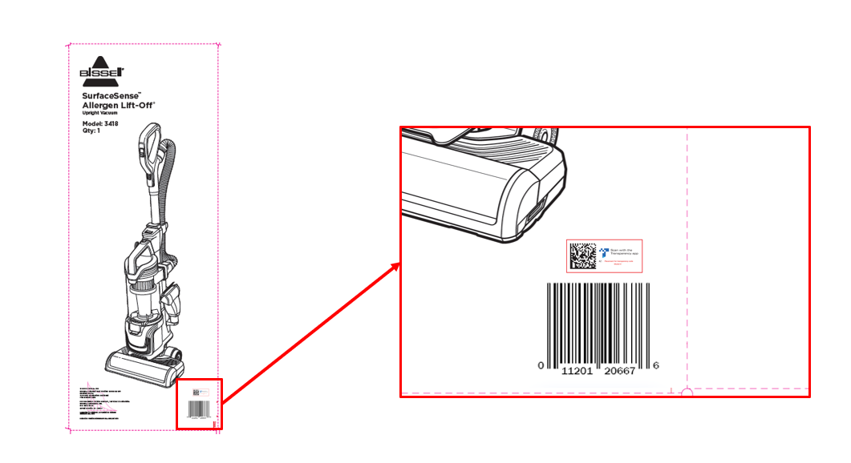
- Repalletize the unit in accordance with 3418 pallet requirements.

