List all Part Number and/or Components Required:
Part Number | Description
3288 | Big Green 2.0
1990 | 48oz Pet Pro Oxy Urine Eliminator

Instructions:

- Get a 3288 unit
- Get a 1990 - 48oz Pet Pro Oxy Urine Eliminator formula bottle
- Open the 3288 carton and remove the machine, keep all packaging contents and remember how it is packaged
- Locate the dirt tank
- Wrap 1 bottle of 1990 in bubble wrap and place into the dirt tank as shown below: 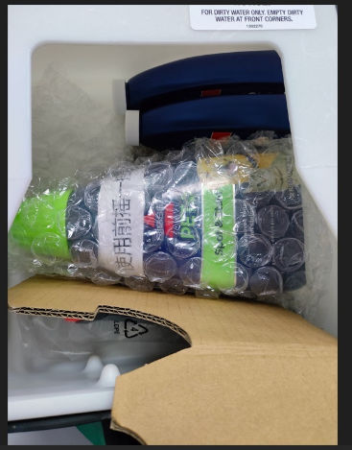

- Reassemble the 3288 machine and packaging as it was and place back into the carton
- Tape up carton and place on a pallet according to the 3288 pallet instructions on Intraclean

