List all Part Number and/or Components Required:
Part Number | Description
1947T | CrossWave® Display Model
1629167 | DPCI Sticker
1629169 | Display Sticker

Instructions:

- Grab a 1947T CrossWave Display in the carton.
- Add six ‘DPCI Sticker’ Labels on four side panels, top panel, and bottom panel where clearly visible. If ‘DPCI Sticker’ Labels are currently present on carton, ensure 1629167 label covers up any old versions of the labels.
  - Refer to image below.
- Add six ‘Display Sticker’ Labels on four side panels, top panel, and bottom panel where clearly visible. If ‘Display Sticker’ Labels are currently present on carton, ensure 1629169 label covers up any old versions of the labels.
  - Refer to image below.
- Repalletize according to pallet configuration for 1947T.

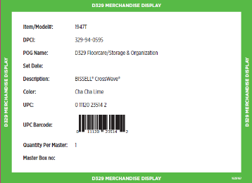
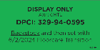
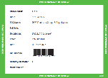
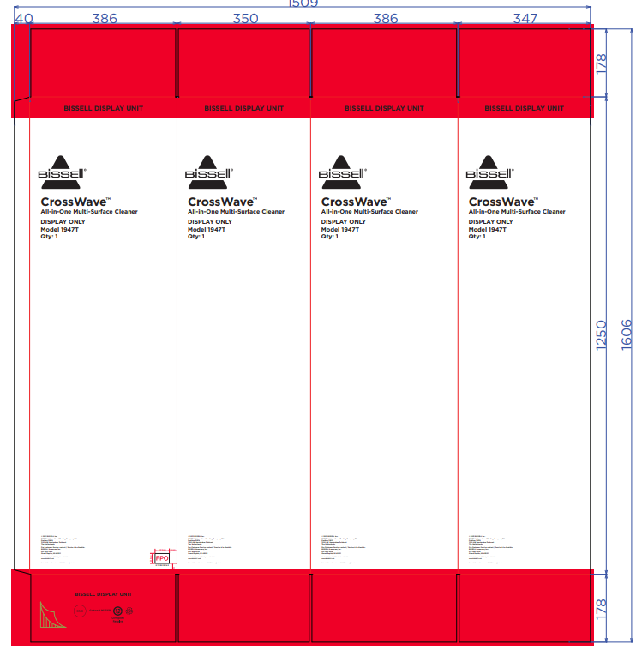
1629167
DPCI Sticker:
1629169
Display Sticker:

