List all Part Number and/or Components Required:
Part Number | Description
1947M | CrossWave® Display Model
1645089 | DPCI Sticker

Instructions:

- Grab a 1947M CrossWave Display in the carton.
- Add four ‘DPCI Sticker’ Labels on four side panels where clearly visible. If ‘DPCI Sticker’ Labels are currently present on carton, ensure 1645089 label covers up any old versions of the labels.
  - Refer to image below.
- Repalletize according to pallet configuration for 1947M

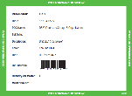

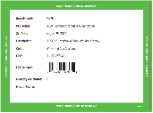
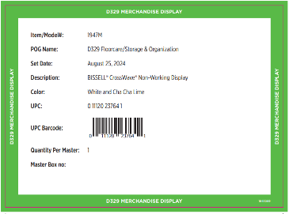
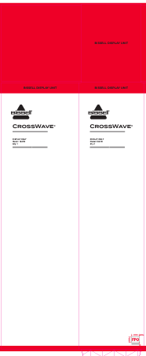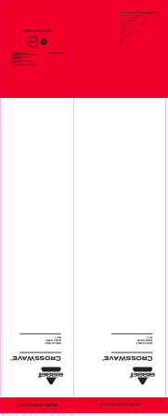
1645089
DPCI Sticker:

