List all Part Number and/or Components Required:

Marketing | Marketing | Procurement | Procurement
Part Number | Description | Supplier | Delivery Time
2513W | SpotClean ProHeat
N/A | UPC/Model # Stickers (UPC: 011120268492, Model #: 2513U)  Print at warehouse

Instructions:

- Take unit of 2513W from inventory
- Place 2513U UPC/Model # Sticker over current UPC/Model # as pictured below.
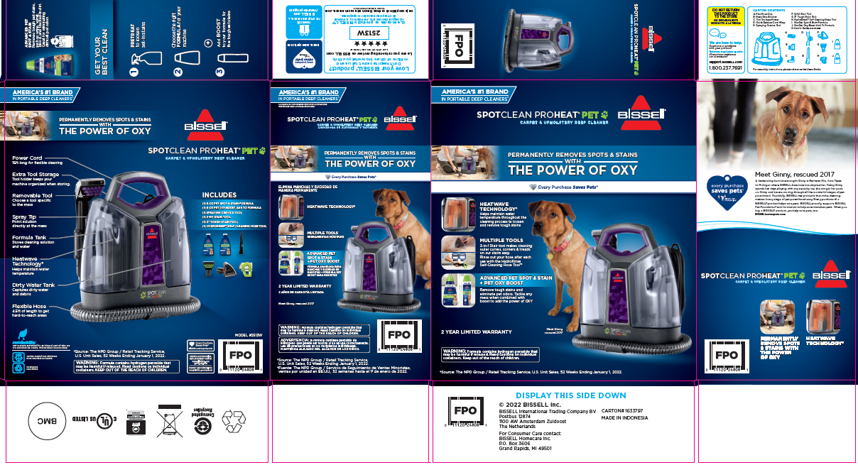
- Repalletize per 2513U instructions on supplier site

