List all Part Number and/or Components Required:

Marketing | Marketing | Procurement | Procurement
Part Number | Description | Supplier | Delivery Time
3907 | Little Green HydroSteam Pet | Donlim
2038G | Little Green Formula | BHI
1644085 | Little Green HydroSteam Pet 39071 Carton | Green Bay Packaging

Instructions:

- Take unit of 3907 from inventory
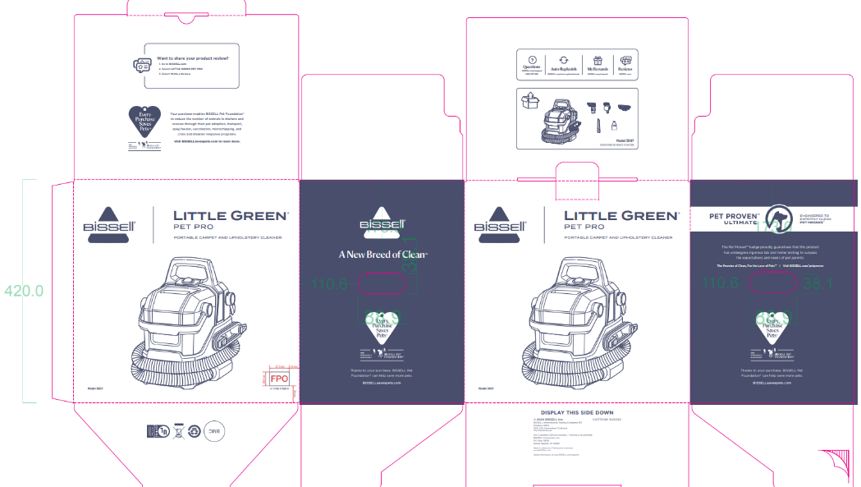

- Take one formula bottle of 2038G from inventory
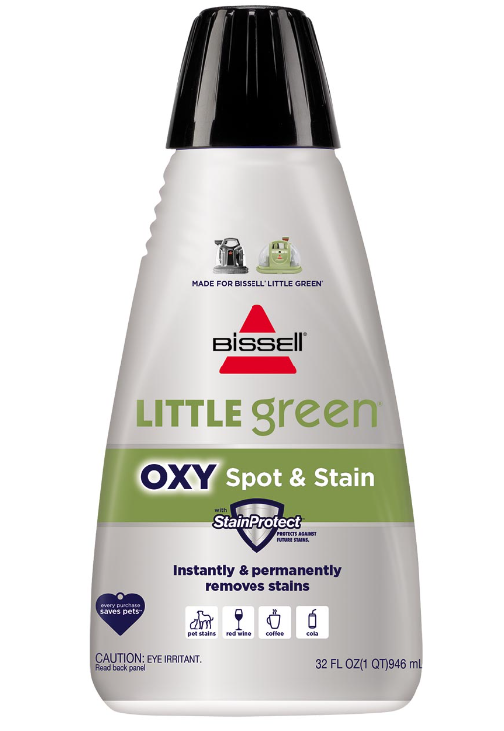
- Grab part number 1644085 (39071 carton)
- Pack both the 3907 and 2038G formula into the 1644085 (39071) carton
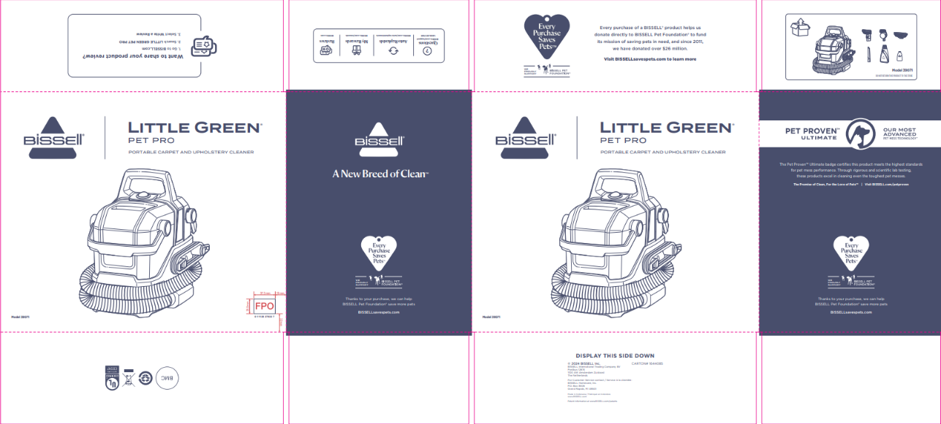
- Place bubble wrap or alternative packing material to make sure everything is secure in box
- Repalletize per 39071 instructions on supplier site

