List all Part Number and/or Components Required:
Marketing | Marketing | Procurement | Procurement
Part Number | Description | Supplier | Delivery Time
3907 | Little Green Pet Pro | Donlim | 10/1/24
1644112 | Tank Sticker POP | Grandville Printing | 10/1/24
1644113 | Handle Sticker POP | Grandville Printing | 10/1/24
1645197 | VPP Sticker | Grandville Printing | 10/1/24
 | 3903 Model Number Label | Jessica Humble | 10/1/24

Instructions:
- Take unit of 3907
- Take all contents out of box.
- Cut prongs off cord
- Place Tough Stain Tool on Tool Holder
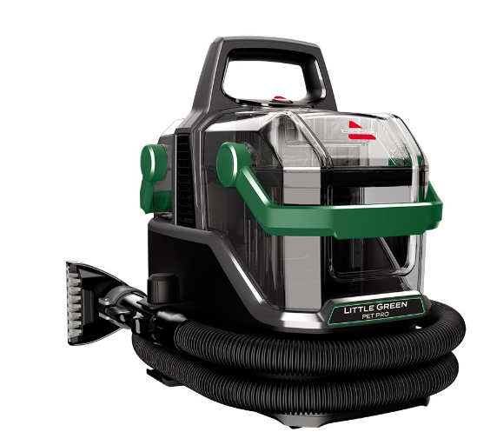

- Glue Crevice Tool on to Tool Holder
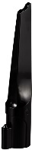

- Lift up handle and place the Tank Sticker (1644112) onto the front of the tank.



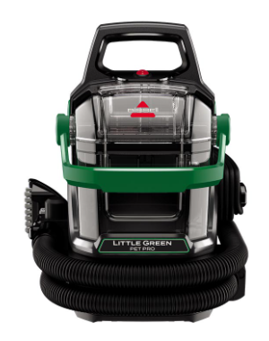

- Place the Handle Sticker POP (1644113) on the green handle of the unit.



- Apply VPP sticker to the back of the machine.

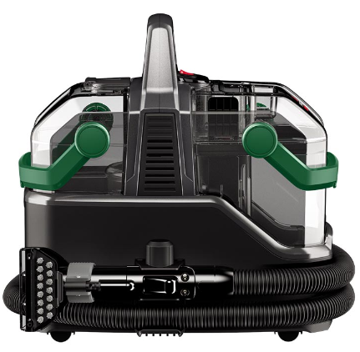

- Place the 3903 Model Number Label over the 3907 number on the carton.

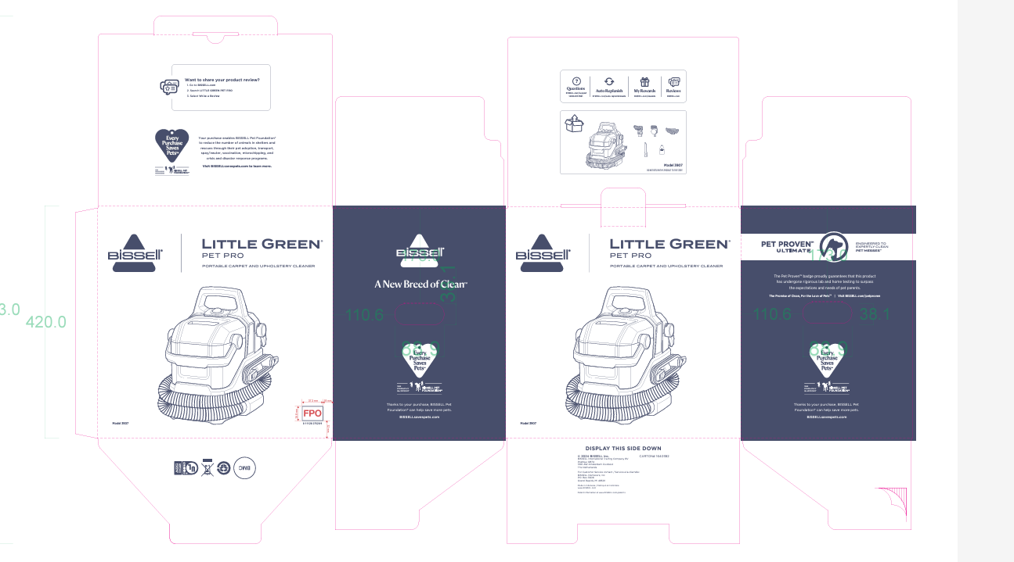

- Add the red Product Flow Team label to the front of the carton.

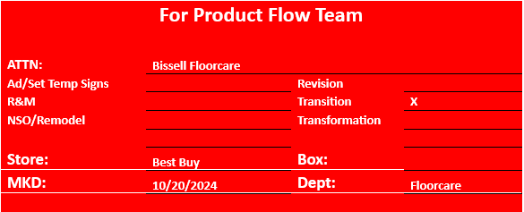

- Repalletize per the 3903 pallet diagram on the supplier site. Stain Trapper Tool and Rubber Nubs are not included in product and should be left out of the carton.

