**List all Part Number and/or Components Required:**

|  |  |
| --- | --- |
| **Part Number** | **Description** |
| 3897A | SpinWave SmartSteam |
| 1641748 | Side Talker POP |
| 1641747 | Body Sticker POP |
| 1641744 | UPC Barcode Sticker |
| 1641745 | DCPI Sticker x6 per unit |
| 1641746 | Green Display Only Sticker x6 per unit |
| 1641743 | Kraft Carton shipped to DC from Green Bay Packaging |

**DC CONVERSION INSTRUCTIONS**

1. Get a 3897A SpinWave SmartSteam working unit

1. Open 3897A Kraft Carton and remove machine and contents.
   1. Machine will be repackaged into kraft carton part #1641743
   2. Assemble unit (Instructions below)

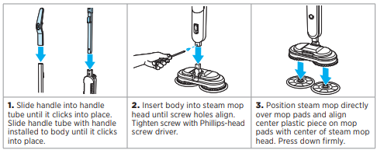

* 1. The extra set of mop pads will not be used. Dispose or place in bin to keep
  2. Cut the power cord so that the plug with the prongs are removed

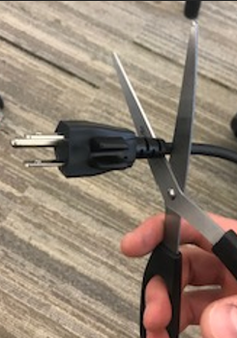

* 1. Wrap the cord (with the plug and prongs cut off) around the upper and lower cord wrap, zip tie the power cord to prevent it from unraveling

1. Peel off the PRL label (reference image below) located on the back, bottom foot of the machine

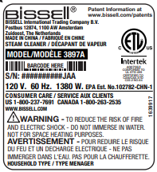

1. Attach UPC barcode sticker, 1641744 in the same spot the PRL was previously located as shown below.

1. Apply POP

**POP:**

* Remove adhesive backing from Body Sticker POP (part #1641747) and place on the front of the machine towards the bottom of the body

* Bend side talker backward along left side of artwork where dotted line instructs to and remove adhesive backing from the left side of the side talker (part #1641748). Place adhesive strip on the right side of the machine as you face it so the side talker artwork is facing toward you

1. Place **FULLY ASSEMBLED** unit into the part #1641743 kraft carton
   1. Bubble Wrap unit and conceal unit by taping bubble wrap
   2. Place unit into carton
   3. Fill voids inside carton with buddle wrap
   4. Tape carton shut
2. Place DPCI Carton label (part #1641745) on all 6 panels of the carton (4 sides, top and bottom)

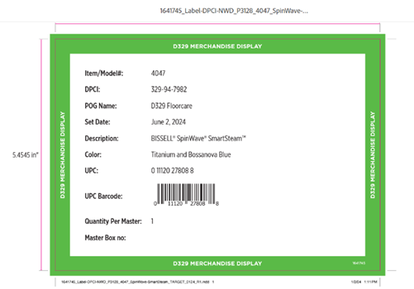

1. Place Green Display Only Label (part #1641746) on all 6 panels of the carton (4 sides, top and bottom)

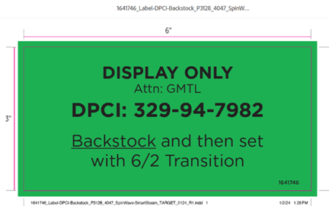

1. Place Carton Label below on front and back of the carton

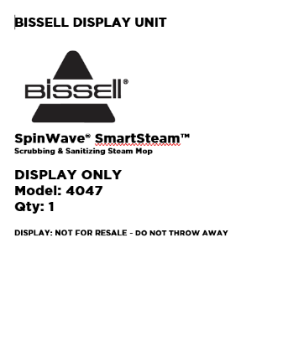

1. Place units on pallet as per below

