List all Part Number and/or Components Required:
Part Number | Description
3896 | PowerForce Pet Turbo XL
1639133 | Side Talker POP
1639997 | Banner
1639998 | Clean Tank (upper tank) Sticker POP
1628462 | Dirt Tank (lower tank) Sticker POP
1625946 | Foot Talker POP
1639132 | UPC Barcode Sticker – WM x2 per unit
1639136 | SAP Sticker x4 per unit
1636430 | Anderson Label x4 per unit
1642752 | Kraft Carton shipped to DC from Green Bay Packaging
N/A | POP Clips included with POP shipments
N/A | Zip Ties provided by DC and/or Grandville Printing Company

DC CONVERSION INSTRUCTIONS
- Get a 3896 PowerForce Pet Turbo XL working unit

- Open 3896 Litho Carton and remove machine and contents.
  - Machine will be repackaged into kraft carton part #1642752
  - Assemble unit (Instructions below)
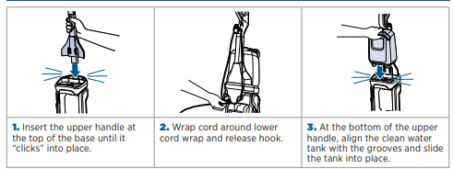
  - 3” Tough Stain Brush, Pet Stain Tool, Mesh Bag, Nozzle Clean Out Tool and Formulas will not be used. Dispose or place in bin to keep
  - Cut the power cord so that the plug with the prongs are removed
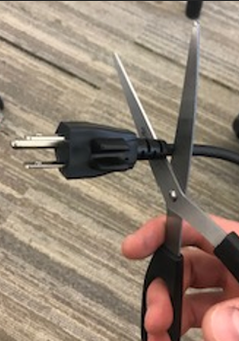
  - Wrap the cord (with the plug and prongs cut off) around the upper and lower cord wrap, zip tie the power cord to prevent it from unraveling

- Peel off the PRL label (reference image below) located on the back, bottom foot of the machine
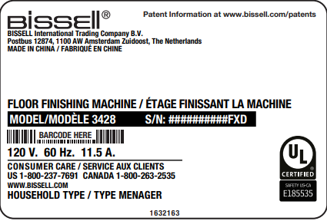

- Attach UPC barcode sticker, 1639132 in the same spot the PRL was previously located as shown below.
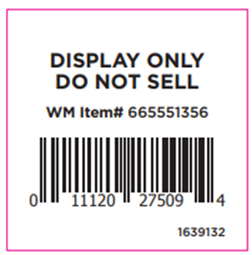

- Apply Banner (PN 1639997) to the front of the handle via adhesive strip as shown below (there are two foam guides that the handle will fit between), ensuring the banner loops infront of the handle on the unit:
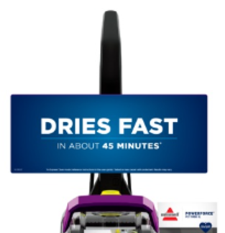

- Apply POP
POP:
- Remove adhesive backing from Dirt Tank (lower tank) Sticker POP (part #1628462) and place in the center of the lower tank
- Remove adhesive backing from Clean Tank (upper tank) Sticker POP (part #1639998) and place in the center of the lower tank
- Remove adhesive backing from POP clip and place clip on right side of machine (2-3 clips may be needed to position side talker evenly and securly). Place the Side Talker POP (part #1639133) in the clip(s). Ensure the side talker is sitting upright along length on the side of the unit
- Bend foot talker backward at base of artwork where dotted line instructs to and remove adhesive backing from bottom of Foot Talker (part #1625946). Place adhesive strip face down on the foot/nozzle of the machine so foot talker artwork is facing toward you

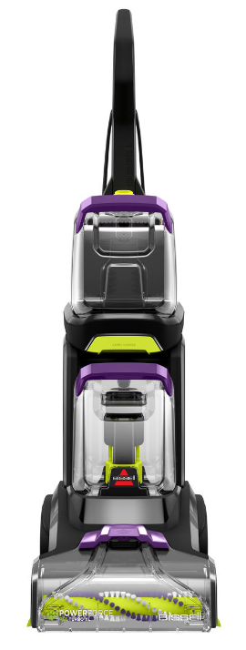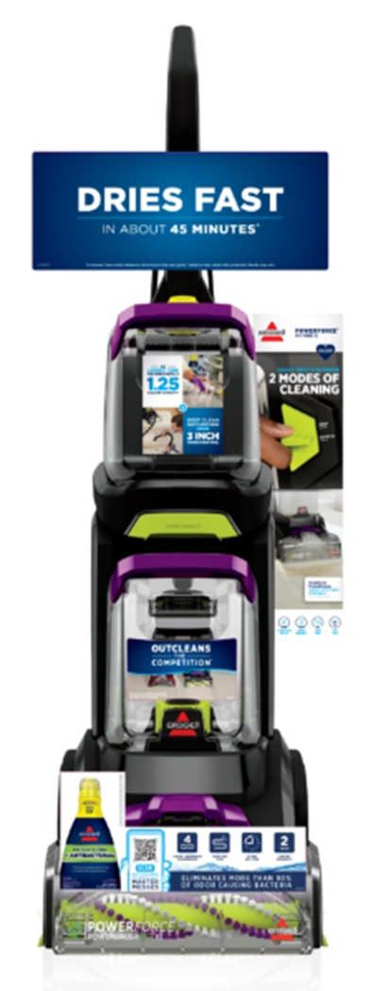

- Place FULLY ASSEMBLED unit into the part #1642752 kraft carton
  - Bubble Wrap unit and conceal unit by taping bubble wrap
  - Place unit into carton
  - Fill voids inside carton with buddle wrap
  - Tape carton shut

- Place SAP Carton label (part #1639136) on all 4 sides of carton
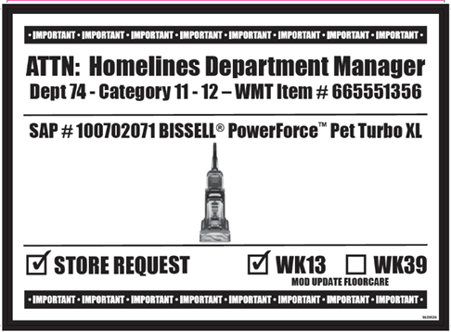

- Place Anderson Label (part #1636430) on all 4 sides of the carton, below the SAP label
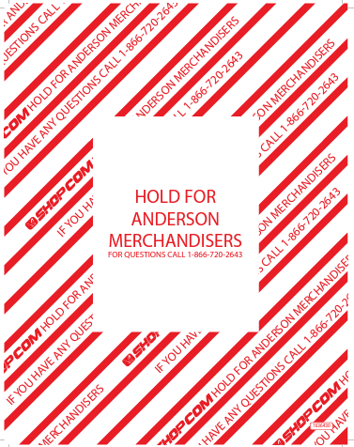
- Place a UPC Sticker (part #1639132) on bottom right corner of one of the larger panels
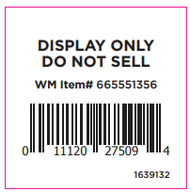

- Cartons with labels should appear as shown below:
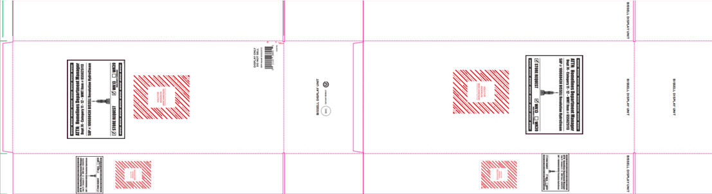

- Place units on pallet according to 3899 pallet instructions on Intraclean.

