List all Part Number and/or Components Required:

Part Number | Description
 | –
3738 | TurboClean Pet XL
1644010 | UPC Barcode / Model Number Label
1638766 | RFID Label

DC CONVERSION INSTRUCTIONS

- Get a MN 3738 TurboClean Pet XL (Litho Carton, 1635809)
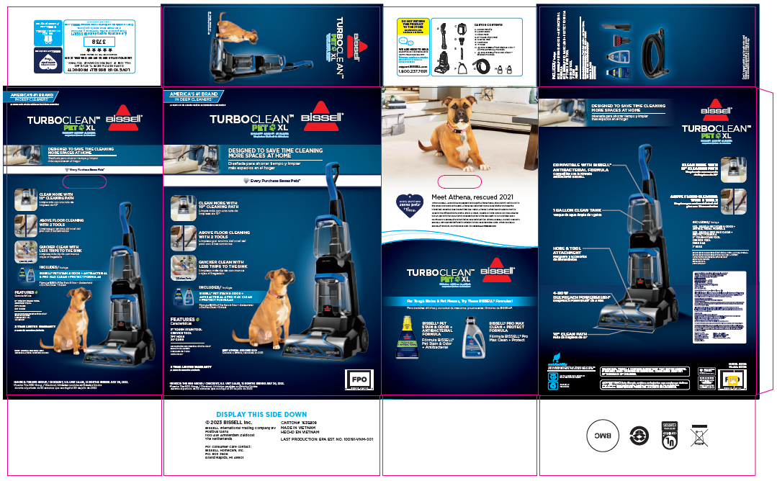

- Place RFID label (PN 1638766) on back panel over top of current UPC, as shown above

- Add a UPC Barcode / Model Number label (PN 1644010) to the other 5 panels of the carton, ensuring they’re covering all other existing UPCs, as shown below

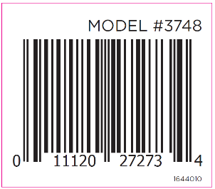

- Place units on pallet according to 3748 pallet instructions on Intraclean

