List all Part Number and/or Components Required:

Marketing | Marketing | Procurement | Procurement
Part Number | Description | Supplier | Delivery Time
3618 | Little Green HydroSteam Pet PDC
1639809 | Little Green HydroSteam User Guide | Grandville
1638909 | Castor Wheels
36058/11120271676 | Model #/UPC Stickers

Instructions:

- Pull a unit of 3618 from inventory

- Open carton and remove current user guide and replace with new user guide p/n 1639809

- Place Castor Wheels 1638909 in carton

- Tape box back up

- Print 36058 model number and UPC (11120271676) and sticker over current model number and UPC as shown below
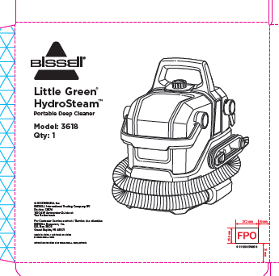

- Repalletize per 36058 instructions on supplier site

