List all Part Number and/or Components Required:

Marketing | Marketing | Procurement | Procurement
Part Number | Description | Supplier | Delivery Time
3605G | Little Green HydroSteam Pet | Donlim
1639855 | Little Green Formula (2038G is FG) | BHI
1639918 | Little Green HydroSteam Pet 3605F Carton | Green Bay Packaging

Instructions:

- Take unit of 3605G from inventory
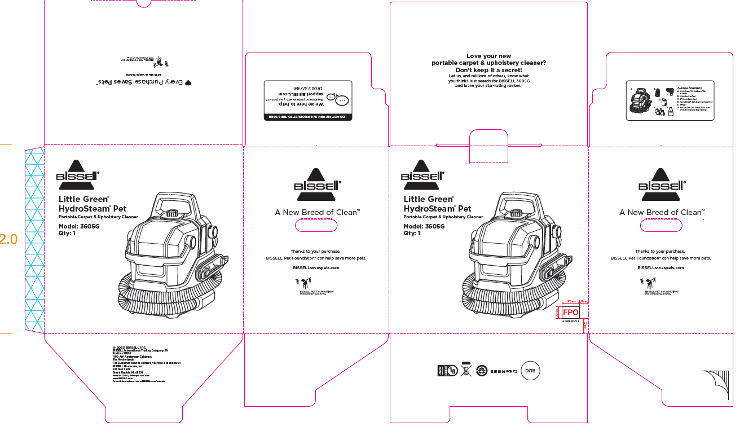

- Take one formula bottle 1639855 (2038G) from inventory
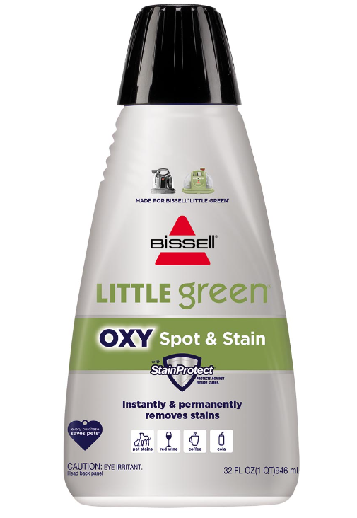
- Grab part number 1639918 (3605F carton)
- Pack both the 3605G and 1639855 (2038G) formula into the 1639918 (3605F) carton
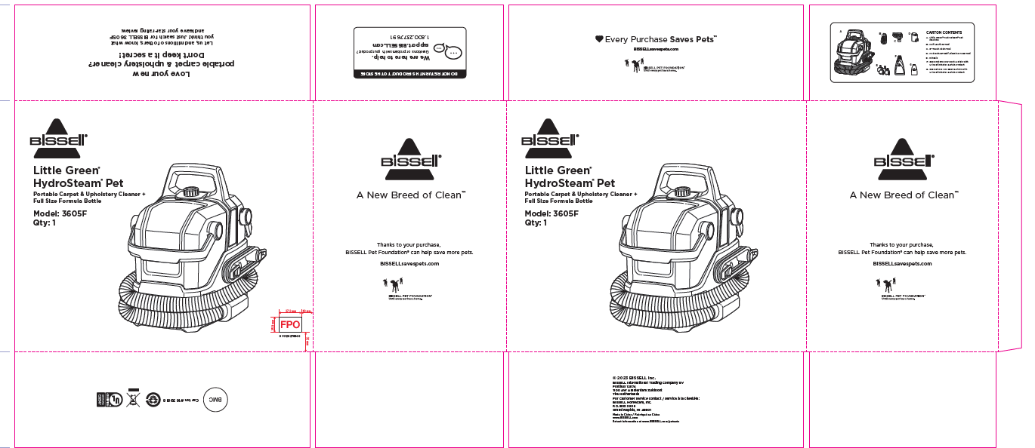
- Place bubble wrap or alternative packing material to make sure everything is secure in box
- Repalletize per 3605F instructions on supplier site

