List all Part Number and/or Components Required:
Part Number | Description
35791 | ProHeat 2X Revolution Pet
1643221 | UPC Machine Sticker
1641730 | Target DPCI Sticker (Green & White) – x6 per carton
1641731 | Target Backstock Sticker (All Green) – x6 per carton
1623032 | POP – Side Talker
1618438 | POP – Clean Tank (Upper Tank) Sticker
1623034 | POP – Dirty Tank (Lower Tank) Sticker
1623033 | POP – Foot Talker
1601522 | Pet Stain Tool – included in 35791 packaging
1643318 | Kraft Carton – shipped to DC from Green Bay Packaging
N/A | Black Zip Ties provided by DC and/or Grandville Printing Company
N/A | White Zip Ties provided by DC and/or Grandville Printing Company

DC CONVERSION INSTRUCTIONS
- Get a 35791 ProHeat 2X Revolution Pet unit

- Open 35791 Litho Carton and remove machine and contents.
  - Machine will be repackaged into Kraft carton 1643318
  - Assemble unit (Instructions below)
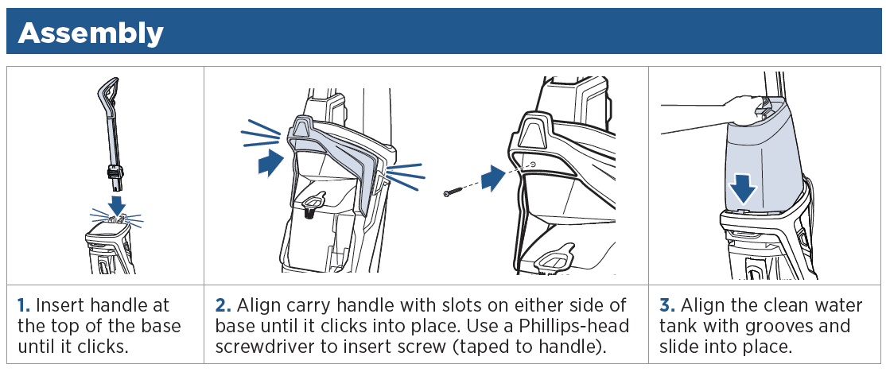
  - Mesh bag, hose, 3” Tough Stain tool, nozzle clean out tool and formulas will not be used. Dispose or place in bin to keep. SET ASIDE the Pet Stain Tool (photo below)
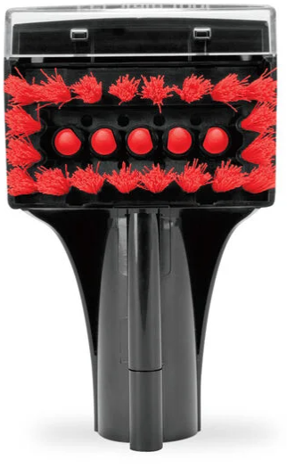
  - Cut cord located on the back on the unit below the bottom tank
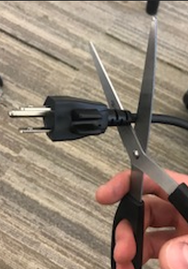
  - Zip tie cut cord together and wrap around carry handle and lower cord wrap.

- Peel off PRL label (image below), located on the back, bottom foot of the machine that is labeled MN 35791 so that no information on the label is visible from the sticker.
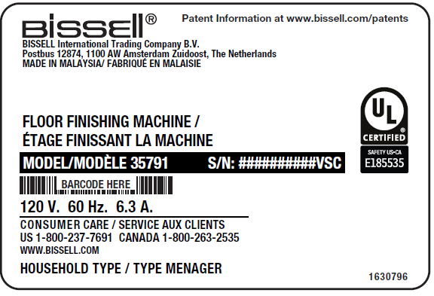

- Attach UPC barcode sticker, (PN 1643221) in the same spot the PRL was previously located as shown below.
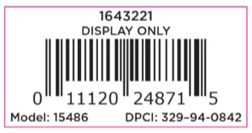

- Apply Pet Stain Tool (PN 1601522) to left side of the Side Talker (PN 1623032) via 2 BLACK zip ties. Ensure the Pet Stain Tool is securely fastened and facing with the bristles toward the front, as shown in photos below. Cut off extra zip tie ends from the back of the Side Talker. *Please note that exact color of POP will vary between photos and actual parts

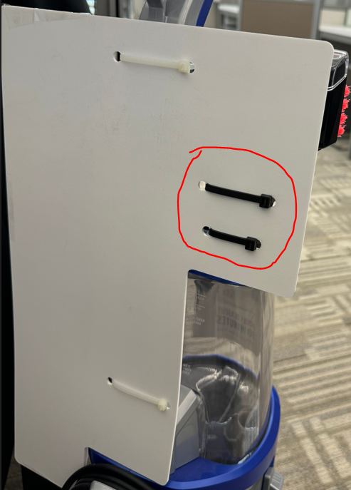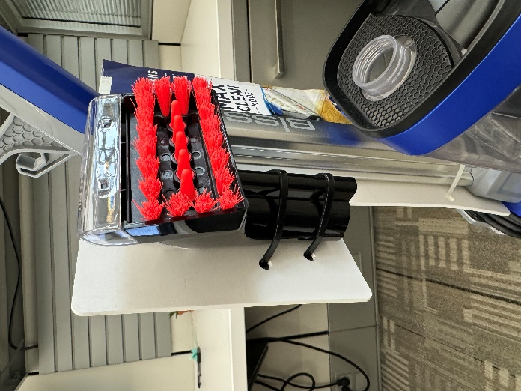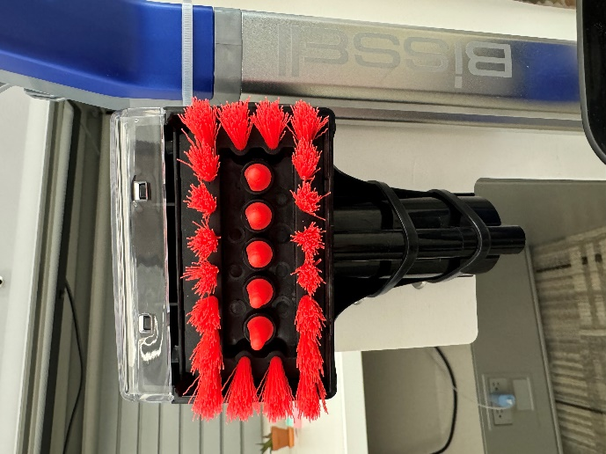

- Apply Side Talker (PN 1623032) with attached Pet Stain Tool to the unit by securing it to the back of the handle via 2 WHITE zip ties as shown in photos below. The top of the Side Talker should be just below the cord hook at the back of the handle:

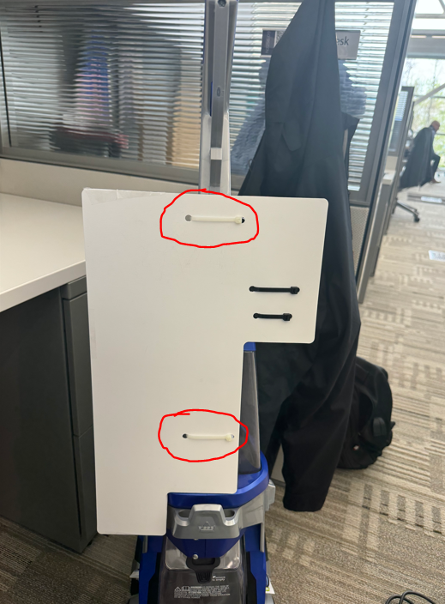
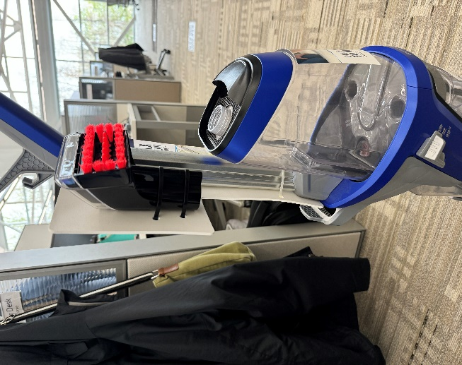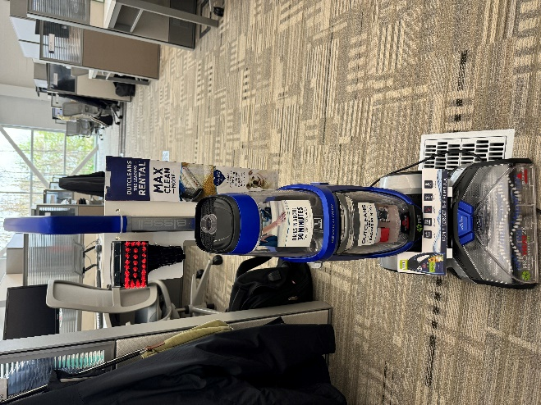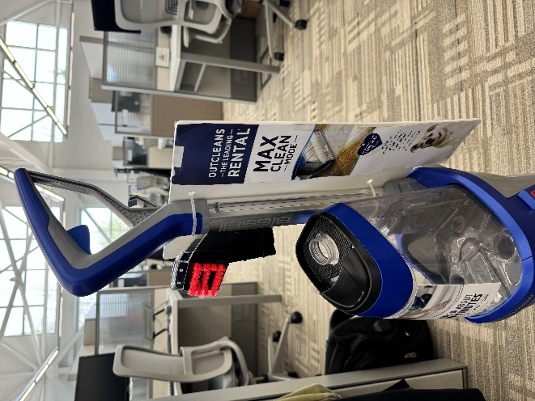
- Remove adhesive backing from Dirty Tank (lower tank) Sticker (PN 1623034) and place in the center of the Dirty Tank

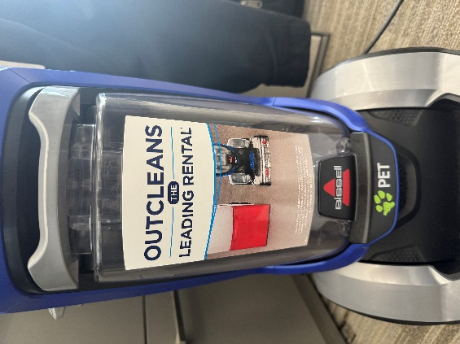

- Remove adhesive backing from Clean Tank (upper tank) Sticker (PN 1618438) and place in the center of the Clean Tank

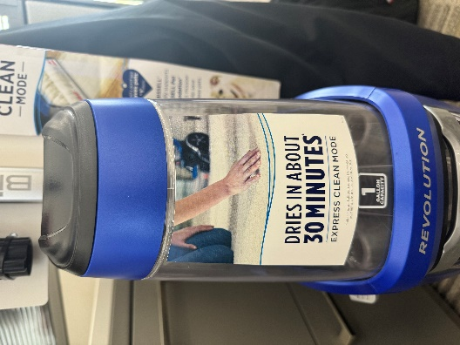

- Remove adhesive from the tape tabs on the Foot Talker (PN 1623033) and fasten to the foot of the machine just behind the blue “Pull To Remove Nozzle” latch, as shown in photos below. Ensure Foot Talker stands up properly.

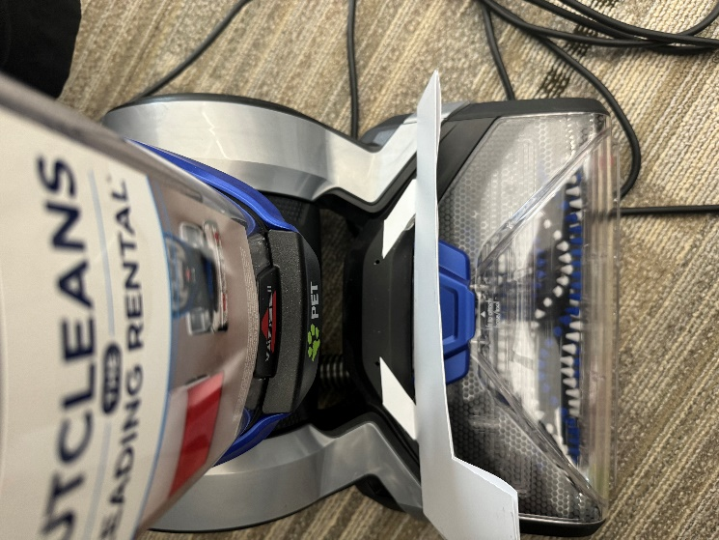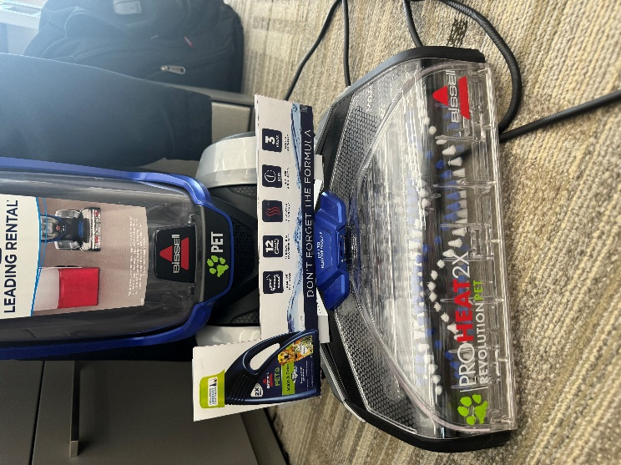

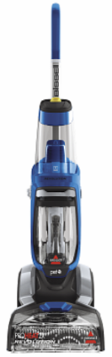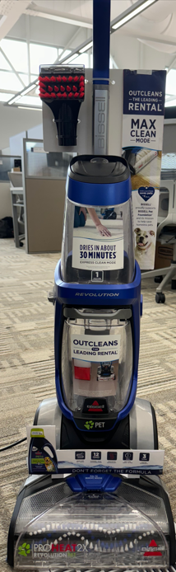

- Place FULLY ASSEMBLED unit into the 1643318 Kraft carton
  - Bubble wrap unit and conceal unit by taping bubble wrap
  - Place unit into carton
  - Fill voids inside carton with bubblee wrap
  - Tape carton shut

- Place a Target DPCI Label (PN 1641730) on all 6 sides of carton
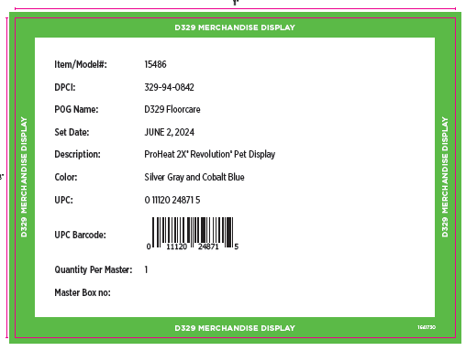

- Place a Target Green Backstock Label (PN 1641731) on all 6 sides of carton

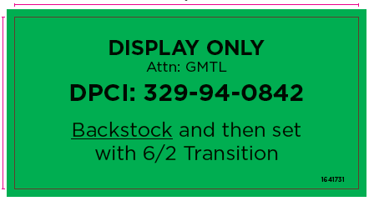

- Cartons with labels should appear as shown below:

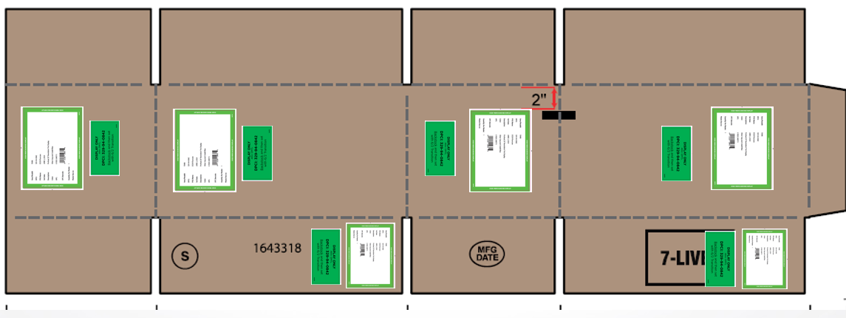

- Place units on pallet according to 2936 pallet instructions on Intraclean.

