List all Part Number and/or Components Required:
Part Number | Description
Model #35151 & UPC: 011120268720 | Warehouse to print stickers and place on cartons
1625325 | Amazon transparency Label

Instructions:

- Get a 35152 unit (Litho Carton, 1630870)
- Add the new model # 35151 and UPC 011120268720 stickers to the back and side panel of the carton, per image below.
  - Be sure all stickers are covering up the current model # 35152 & UPC
  - 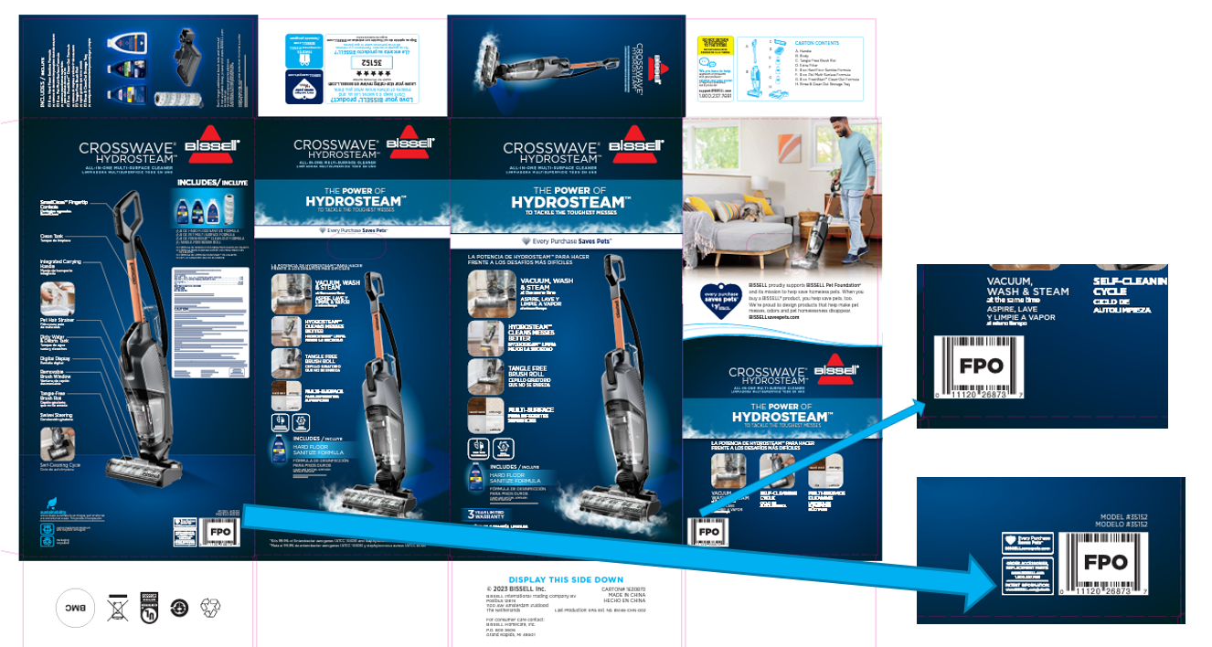

- Add Amazon Transparency Label (Part 1625325)
  - Unique Amazon Transparency Labels to be printed by supplier and sent to DC
  - When applying the Transparency label, allow a minimum of .25” (7mm) between the edge of the label and the edge of the packaging.
  - If placing the Transparency label on the same side/plane as another bar code (UPC, EAN, etc) use a minimum spacing of 1.75” (45mm). If placing above another code, spacing should be minimum of .25” (7mm).
  - Place the Transparency content in a location that is clearly visible and easily accessible to scan.
- Repalletize completed unit per the pallet diagram for item 35151 on supplier.bissell.com

