List all Part Number and/or Components Required:
Part Number | Description
3437 | CleanView Compact Turbo
1644342 | Carton, Kraft - NWD CleanView Compact Turbo NWD - 3761
1631146 | POP, Tank Sticker, CleanView Compact Turbo, 34363
1631144 | POP, Side Talker, CleanView Compact Turbo, 34363

Instructions:
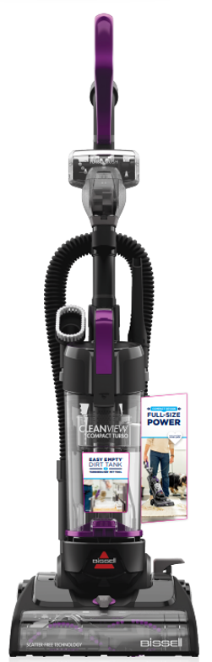
- Ensure 625 units are ordered of model 3437 to the Elwood DC for Meijer & Fred Meyer conversion
  - 275 for Meijer
  - 350 for Fred Meyer
- Remove 3437 from the litho carton & assemble product
- Remove prongs on the cord
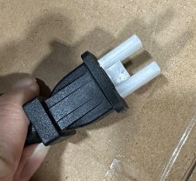

- secure/glue tools on the vacuum
  - TubroBrush Tool, Crevice Tool, Dusting Brush Tool

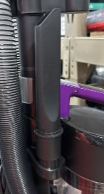
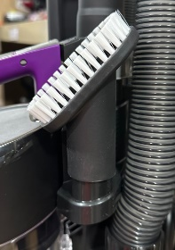
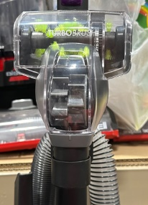

- Remove PRL label and Add NWD UPC sticker on the back of the unit – Label PN: 1644604
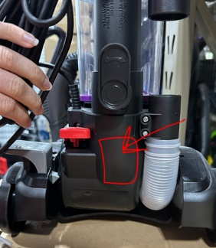

- Add POP sticker to front of dirty tank as shown in example picture – POP PN: 1631146

- Adding POP side talker to Right of tank w/NWD adhesive clips or side talker adhesive - POP PN: 1631144

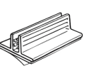

- Printing/utilizing NEW NWD Kraft Carton 1644342 (not part of current model 34363)
  - Will need to print locally from Green Bay Packaging and ship to Elwood DC
- Adding green carton Labels from Sales (Cassie Pfahler to provide to DC)
- We will NOT be needing the Lowe’s reset stickers provided on the product matrix
- (1637242,1637240) as we are using this Lowe’s model for the Meijer reset
- Place FULLY ASSEMBLED unit into 1 of the cartons provided by Green Bay
- Bubble Wrap unit and conceal unit by taping bubble wrap
- Place unit into carton
- Fill voids inside carton with buddle wrap
- Tape carton shut
- Place units on pallet according to 34363 pallet instructions on Supplier Site.

