List all Part Number and/or Components Required:
Part Number | Description
Model #3198A & UPC: 011120262469 | Warehouse to print stickers and place on cartons
1625325 | Amazon transparency Label

Instructions:

- Get a 3198 unit (Litho Carton, Part #1636073)
- Add the new model # 3198A and UPC 011120262469 stickers to the back and side panel of the carton, per image below.

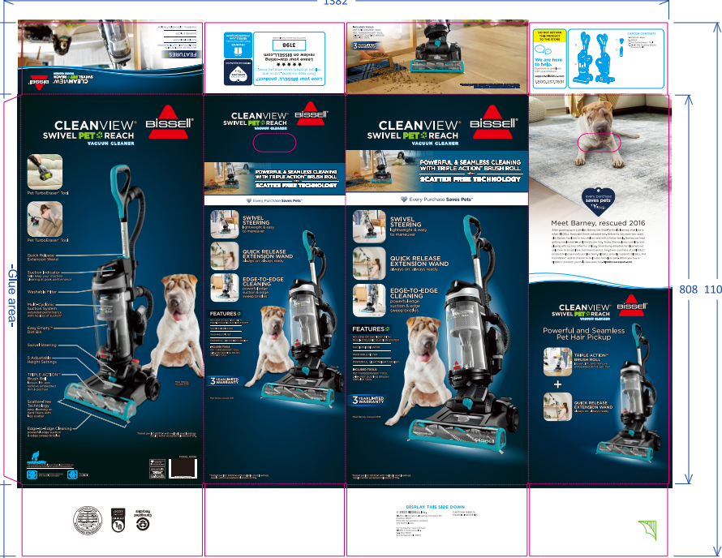
  - Be sure all stickers are covering up the current model # 3198 & UPC

- Add Amazon Transparency Label (Part 1625325)
  - Unique Amazon Transparency Labels to be printed by supplier and sent to DC
  - When applying the Transparency label, allow a minimum of .25” (7mm) between the edge of the label and the edge of the packaging.
  - If placing the Transparency label on the same side/plane as another bar code (UPC, EAN, etc) use a minimum spacing of 1.75” (45mm). If placing above another code, spacing should be minimum of .25” (7mm).
  - Place the Transparency content in a location that is clearly visible and easily accessible to scan.
- Repalletize completed unit per the pallet diagram for item 3198A on supplier.bissell.com

Additional Details:

- Title: Conversion – 3198 Mass to 3198A Amazon CleanView Swivel Pet Reach
- Conversion From: 3198
- Conversion To: 3198A
- Product Name: CleanView Swivel Pet Reach
- Created By: Lauren Seeley
- Approval Date: 3/8/24
- Note: Conversion to add 3198A Model # UPC label and Amazon Transparency Label
- DC Locations:
- Richmond – 5,004 units
- Redlands – 1,008 units
- Seattle – 1,512 units
- Dallas – 1,008 units
- Elwood – 1,512 units
- Part Number:
  - UPC Label – DC’s to Create Label
    - 3198A UPC: 011120262469
  - 3198A Amazon Transparency Label – 1625325
- Richmond: Tracking #: 724108914332
- Elwood: Tracking #: 724108914300
- Seattle: Tracking #: 724108914321
- Dallas: Tracking #: 724108914310
- Description: Take 3198 and add the 3198A UPC label & Amazon Transparency Label near the UPC label
- Supplier: Procurement to populate.
- Delivery Time: Procurement to populate.
- Conversion Start Date: DC’s to populate.
- Completion: Target completion of 4/22

