List all Part Number and/or Components Required:

Marketing | Marketing | Procurement | Procurement
Part Number | Description | Supplier | Delivery Time
1637848 | CleanView Pet Slim Corded Litho Carton | King Clean
1640422 | Label- UPC | To be printed at the DC

Instructions:

- Pull one Cleanview Pet Slim Corded (model #2831) litho carton (p/n 1637848) out of inventory
- Take one label (p/n 1640422) out of inventory and place it on the back panel over the existing UPC/model number

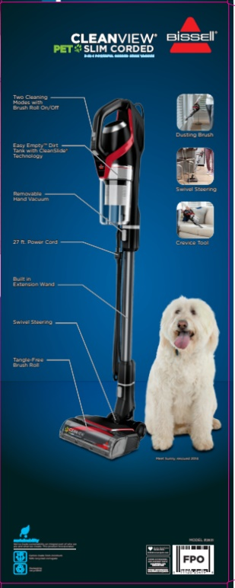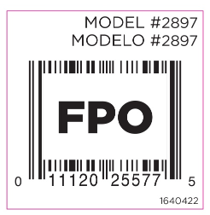

- Place the completed unit on a pallet according to the 2897 pallet instructions below

