List all Part Numbers and/or Components Required:
Part Number | Description
27909 | Pet Hair Eraser Turbo Rewind (working unit)
2790L | Pet Hair Eraser Turbo Rewind (NWD)
1620055 | 2790L Kraft Carton
1620056 | Dirt tank POP #
1620057 | Foot talker POP #
1620058 | Side talker POP #
1600222 | Display Sticker #

Instructions:

- Remove unit 27909 from the original carton. Save all extra packing material for repacking.

- Cut prongs off the cord (will create a non-working display)

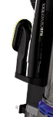
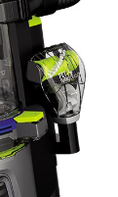
- Secure/glue tools on the vacuum

- Place the Display Only sticker (1600222) on the back of the unit

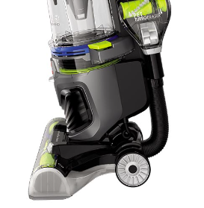

- Place Tank POP (1620056) in the center of the tank.

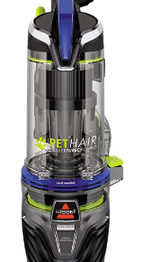

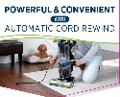

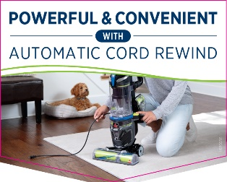

- Take the plastic clip and peel off the adhesive cover and stick it to the right side of the vacuum tank. Slide Side Talker POP (1620058) into the plastic clip
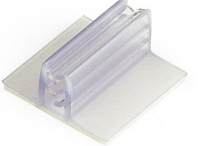
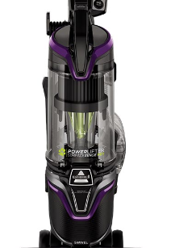
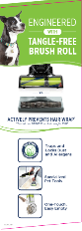
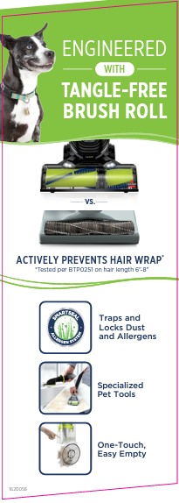

- Take another plastic clip and peel off the adhesive cover and stick it to the left side of the vacuum foot. Slide Foot Talker POP (1620057) into the plastic clip
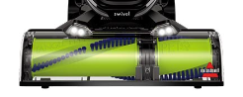
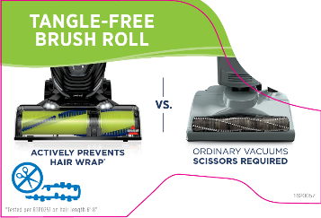

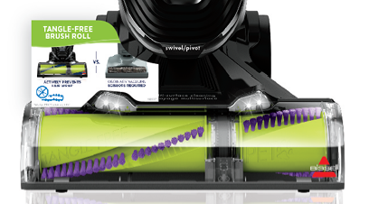

- Once all previous steps are completed, the fully assembled display should look like this:
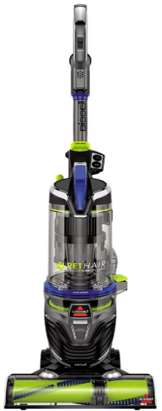
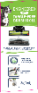

- Take the fully assembled unit and repackage it into the display kraft carton (1620055).
- Tape the carton closed and place it on a pallet in accordance with 2790L pallet requirements.

