List all Part Number and/or Components Required:
Part Number | Description
2316 | CleanView Swivel Pet
23169 | CleanView Swivel Pet NWD
1614760 | 23169 Kraft Carton
1631488 | Dirt Tank POP
1631490 | Foot POP
1631489 | Side Talker POP
1633180 | Blackstock Sticker
1633181 | DCPI Sticker
1633187 | UPC Sticker

Instructions:

- Remove unit 2316 from the original carton

- Cut prongs off the cord (to create a non-working display)

- Secure/glue tools on the vacuum
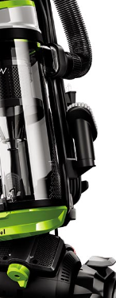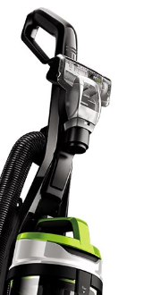

- Place Tank POP (1631488) in center of the tank
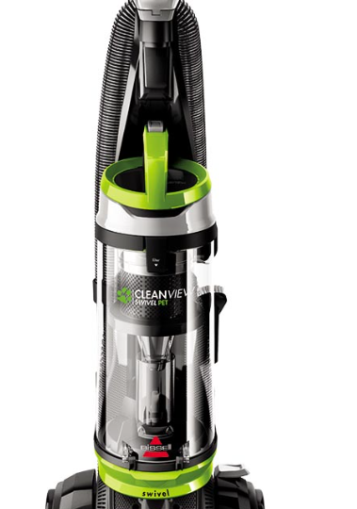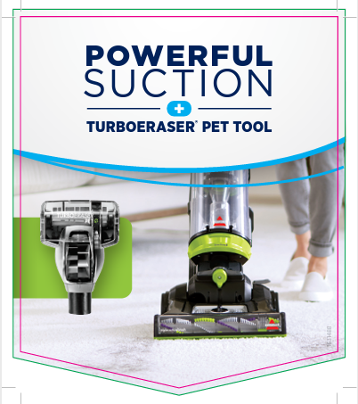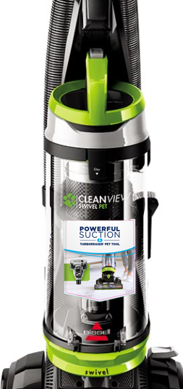

- Take the plastic clip and peel off the adhesive cover and stick it to the right side of the vacuum tank. Slide Side Talker POP (1631489) into the plastic clip
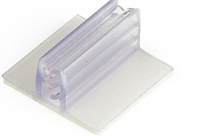
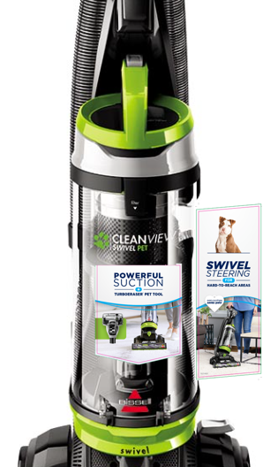

- Take another plastic clip and peel off the adhesive cover and stick it to the left side of the vacuum foot. Slide Foot Talker POP (1631489) into the plastic clip

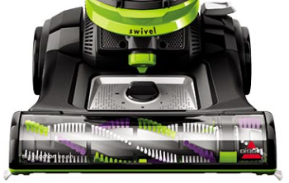
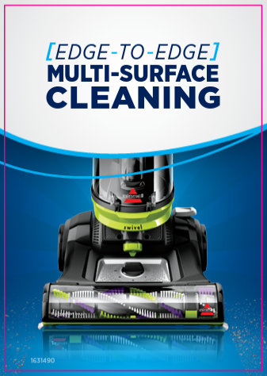

- Once all previous steps are completed, the fully assembled display should look like this: 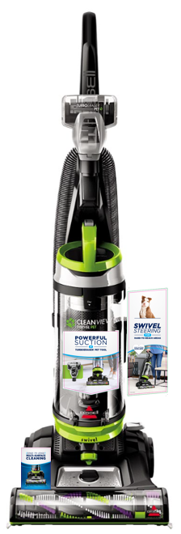

- Place the unit into the kraft carton (1614760) and tape closed.

- Place Backstock Sticker (Part #1633180) on all four side panels. This can be placed anywhere on the side panel as long as it it not covering any text.
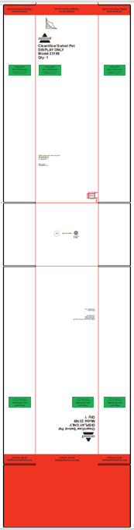

- Place DPCI Sticker (Part #1633181) on all four side panels. This can be placed anywhere on the side panel as long as it it not covering any text.
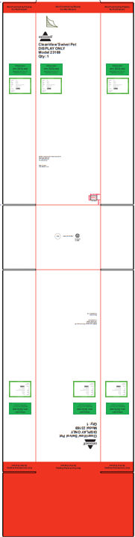

- Place UPC Sticker (Part #1633187) on all four side panels. This can be placed anywhere on the side panel as long as it it not covering any text.
