List all Part Number and/or Components Required:
Part Number | Description
Model # 2328 & UPC: 011120243697 | Warehouse to print stickers and place on cartons
RFID Sticker # 1632114 | Shipped to the DCs and applied to cartons

Instructions:

- Get a 2306 unit (Litho Carton, 1639902)
- Place RFID sticker (PN 1632114) on back panel over top of current UPC, per image below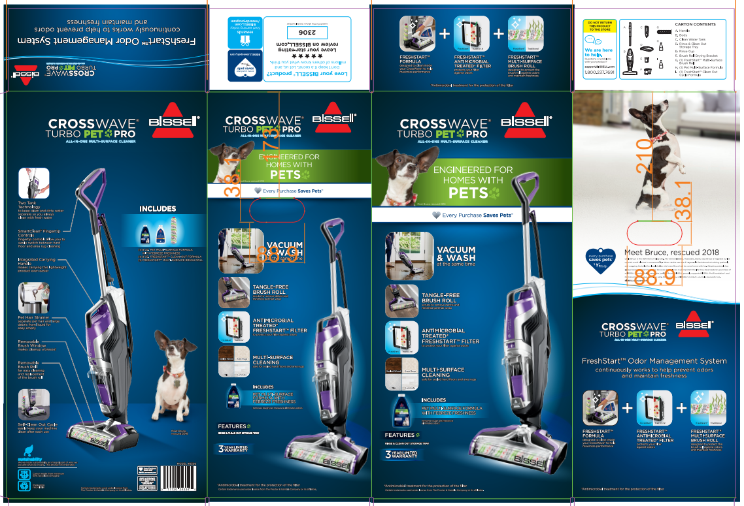 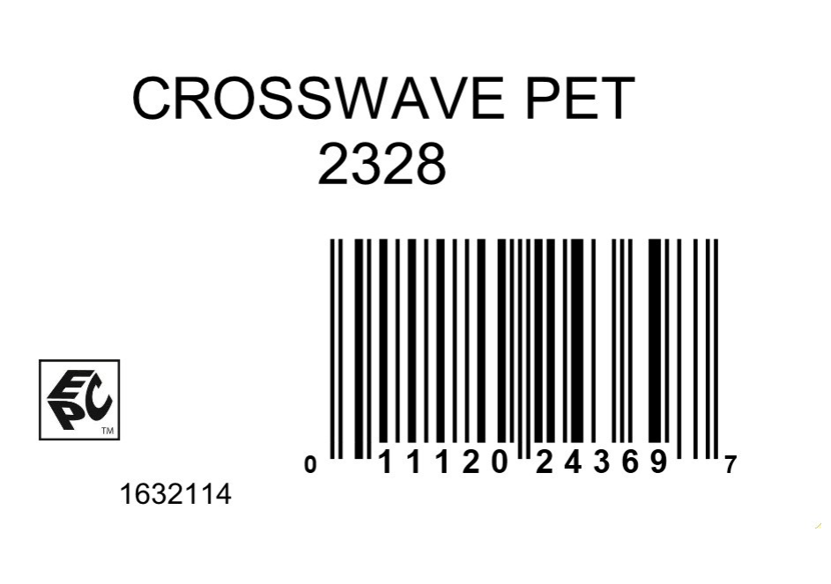
- Add the new model # 2328 to back panel to cover up current model # 2306, per image above

- Add UPC 011120243697 stickers to the 5 panel of the carton, per image below
  - Be sure all stickers are covering up the current UPC
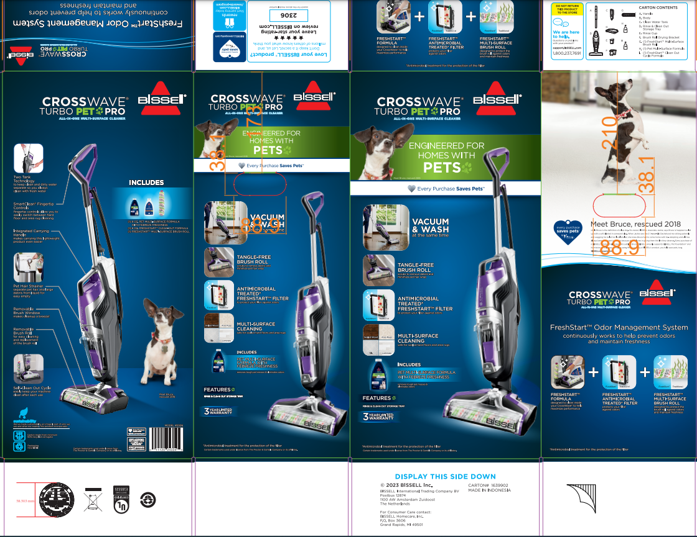
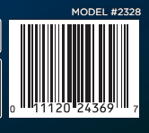
- Repalletize completed unit per the pallet diagram for item 2328 on supplier.bissell.com

