List all Part Number and/or Components Required:

Part Number | Description
1806 | POWERFRESH DELUXE
1636411 | Label - POP, Tank, PowerFresh Deluxe, NWD, EN, USA
1636412 | Label - POP, Lower Body, PowerFresh Deluxe, NWD, EN, USA
N/A | UPC/Model # Sticker (UPC: 011120274912, Model #: 3361F  Print at warehouse

Instructions:

- Get a 1806 PowerFresh Deluxe unit and carefully open the top of the carton.
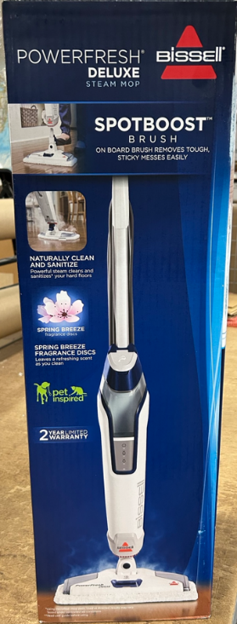
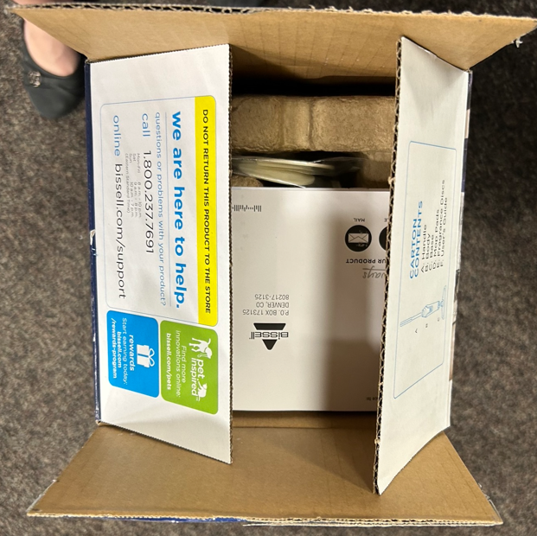

- Remove the Registration Card, Users Guide and plastic wrapped Scent Discs and discard.
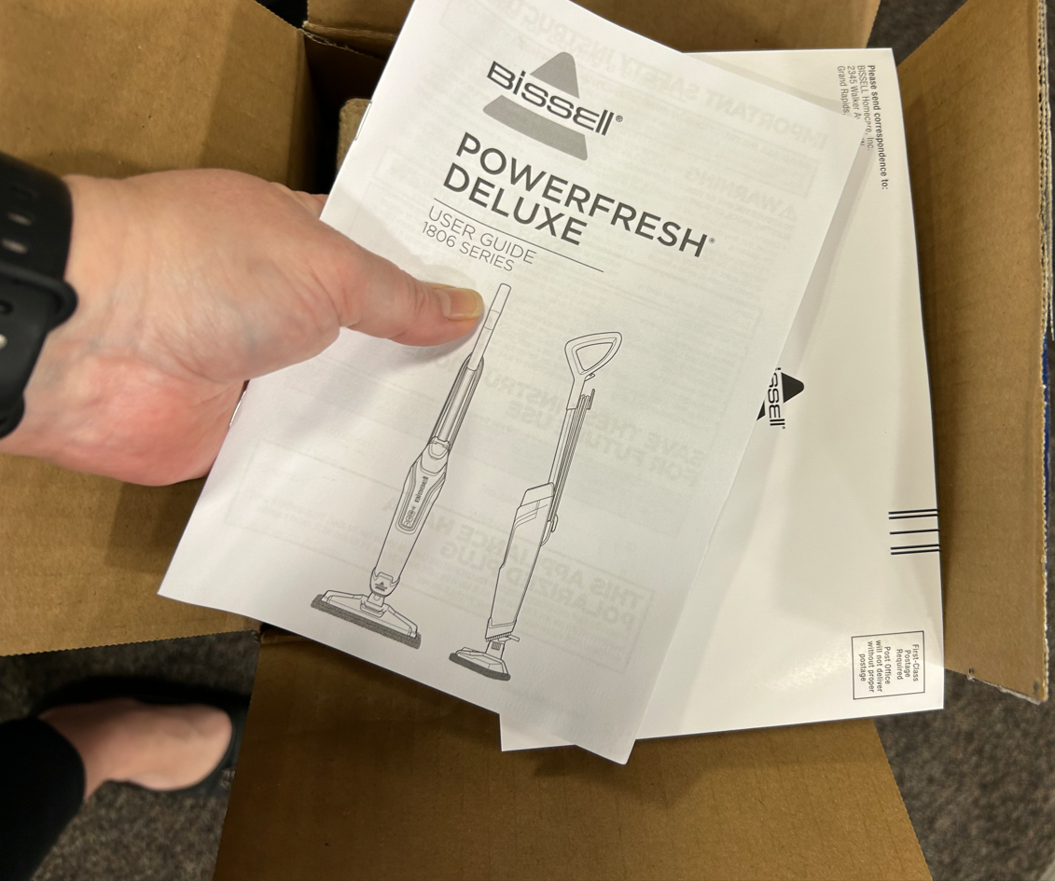

- Remove the plastic wrapped Scent Discs and save to send back to BISSELL, Attn: Trisha Rasch at 2345 Walker Ave. NW, Grand Rapids, MI 49544, Tel 616-350-0455
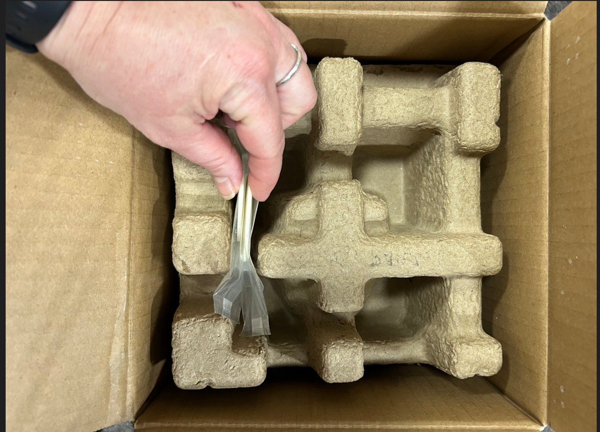

- Remove the top corrugate insert; set aside.
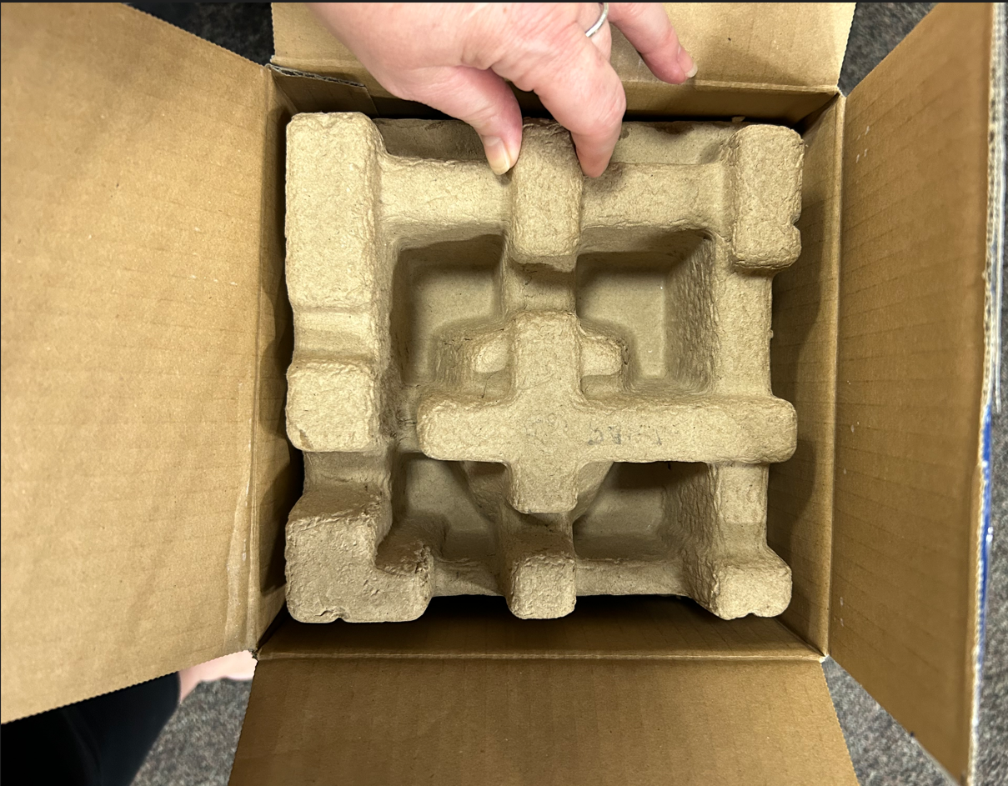

- Remove the handle from the side of the carton; set aside.
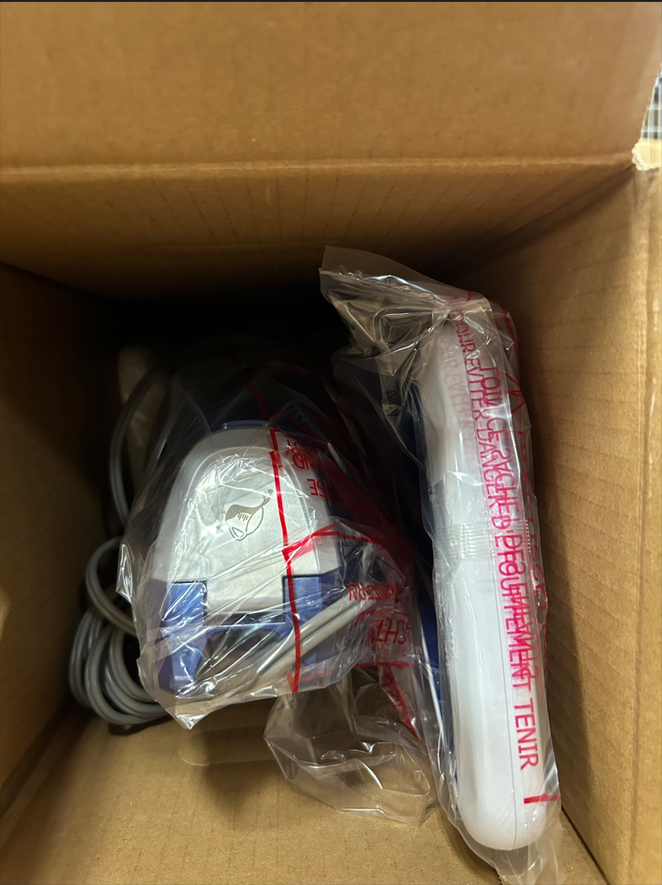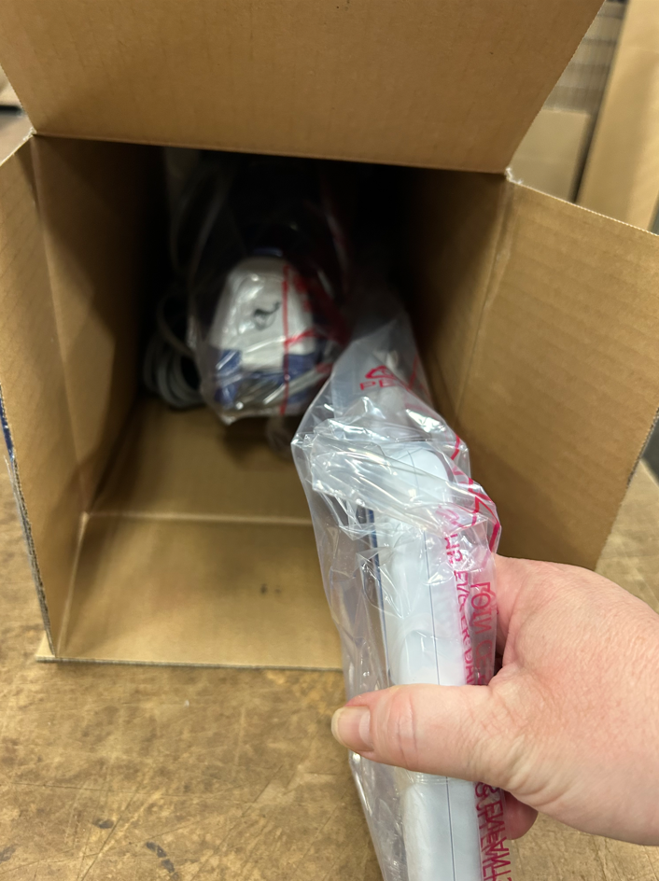

- Remove the unit from the carton and remove the plastic wrap from the the unit; set aside.
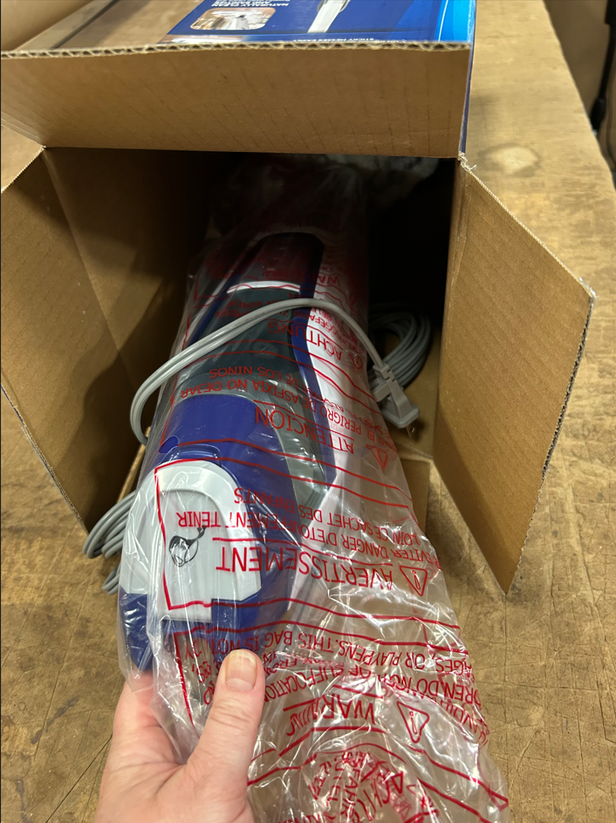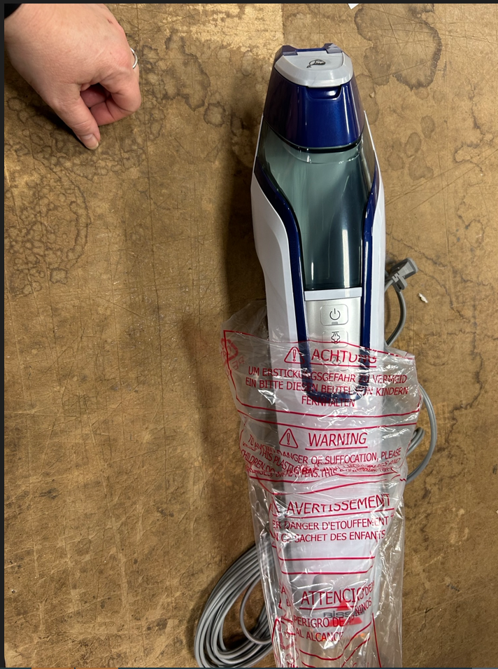

- Remove the extra striped mop pad and save to send back to BISSELL, Attn: Trisha Rasch at 2345 Walker Ave. NW, Grand Rapids, MI 49544, Tel 616-350-0455
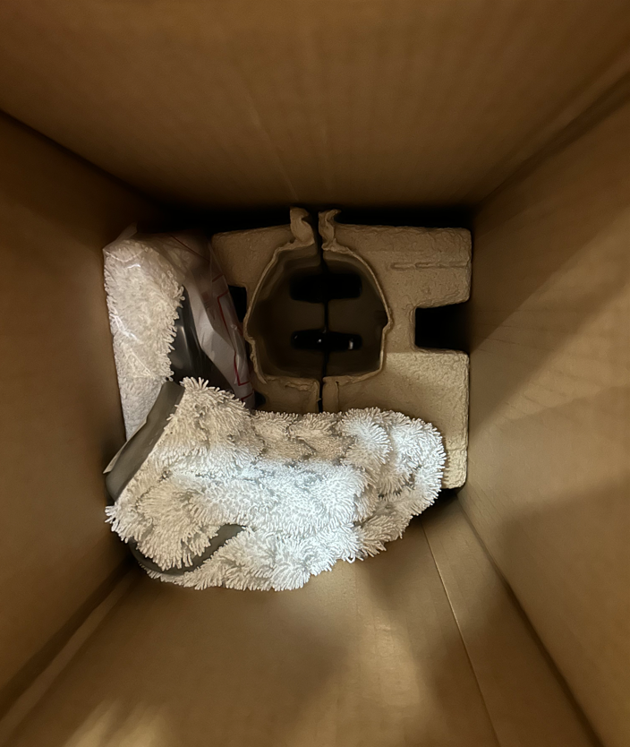

- Apply 1 x part #1636411 Label – POP, UpperTank, PowerFresh Deluxe, NWD, EN USA to the front of the water tank at the top of the unit.
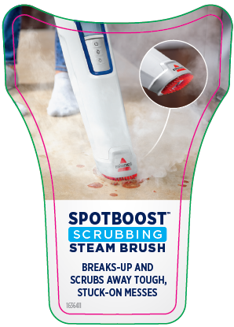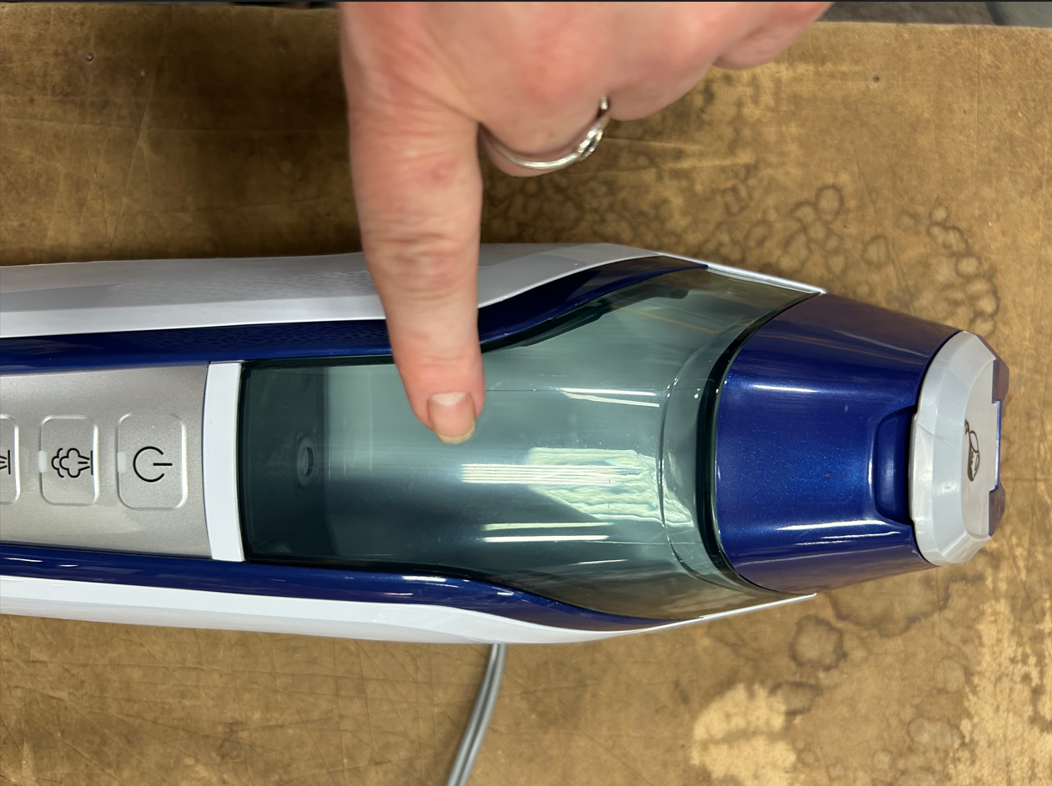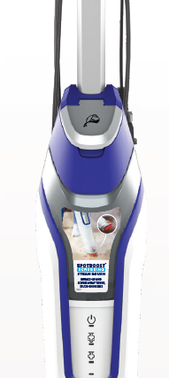

- Apply 1 x part #1636412 Label – POP, Lower Body, PowerFresh Deluxe, NWD, EN USA to the lower body of the front of the unit.
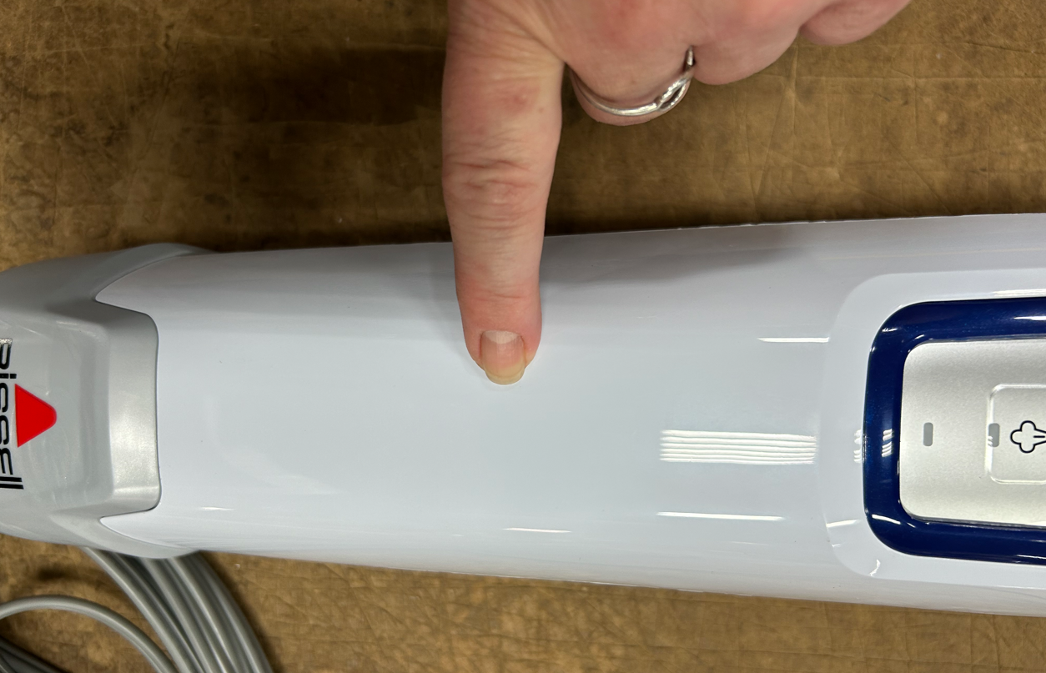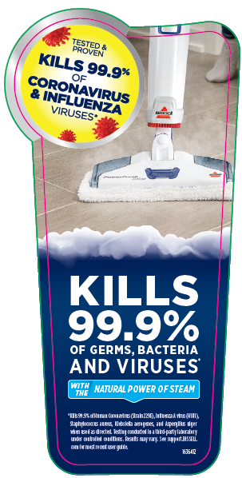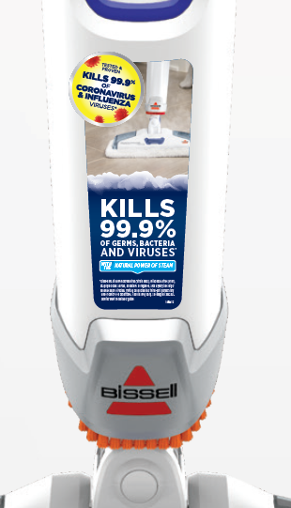

- Place the unit with the two new labels added back into the plastic bag and insert unit back into the carton. Make sure the end with the red brushes is inserted first and make sure the end fits into the large opening in the middle of the bottom corrugate insert. Push the power cord back down into the side of the carton.
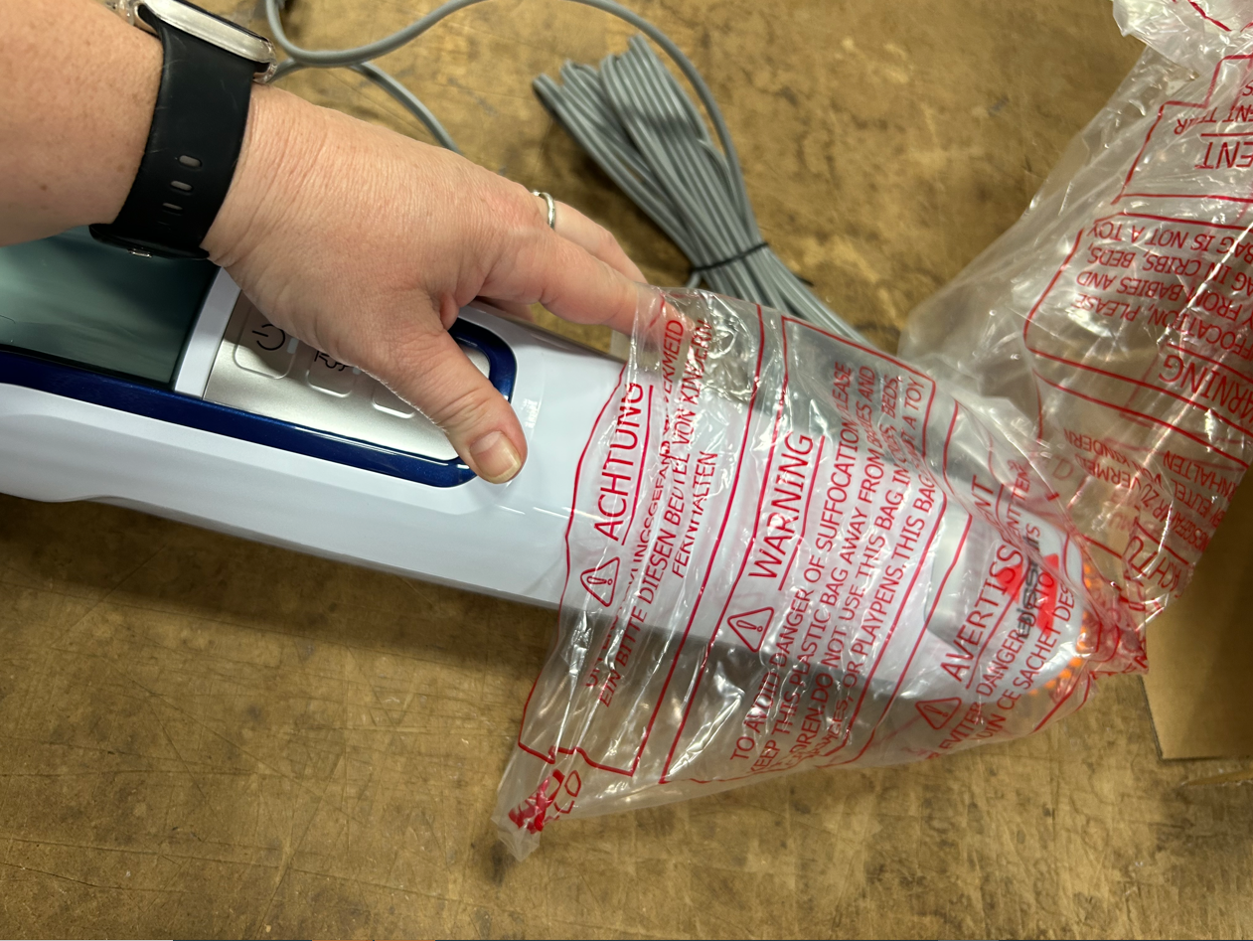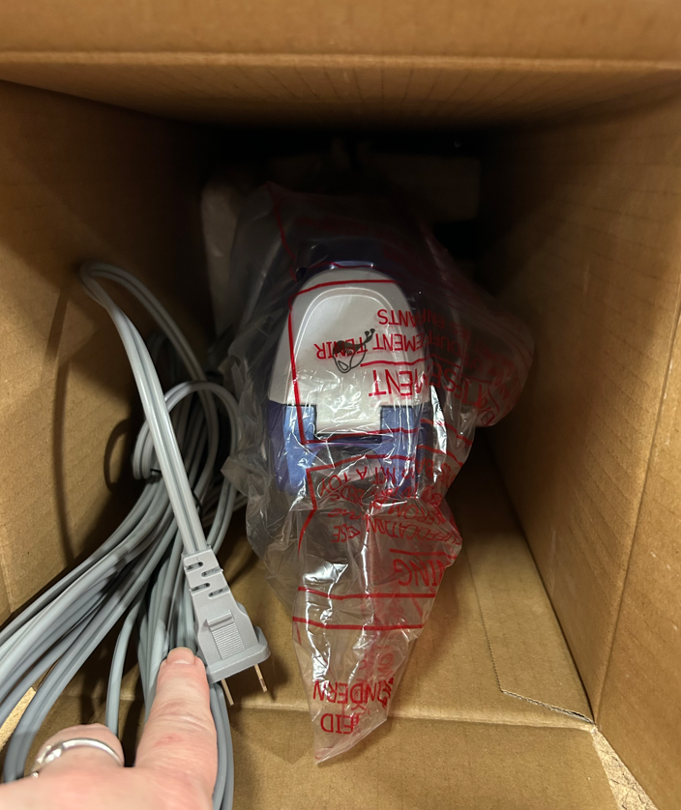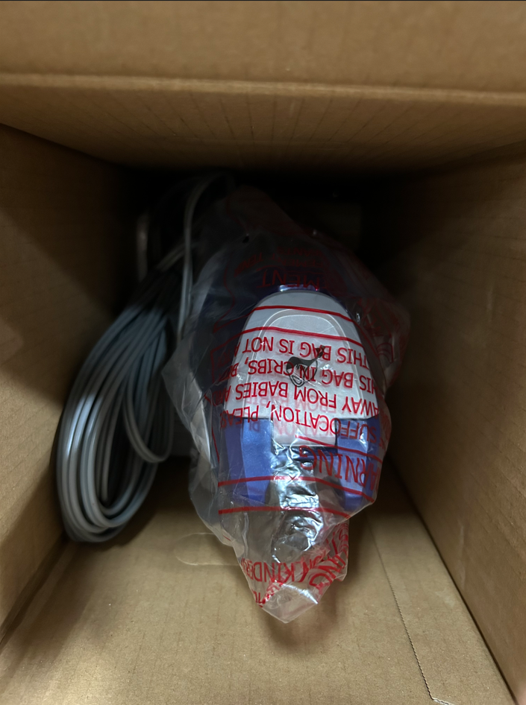

- Place the handle in the plastic bag back into the carton. Make sure the metal tube end is inserted first and make sure the tube end fits into the small opening in the side of the bottom corrugate insert. If inserted correctly, the top of the unit fit into the carton and the flaps will be able to close.
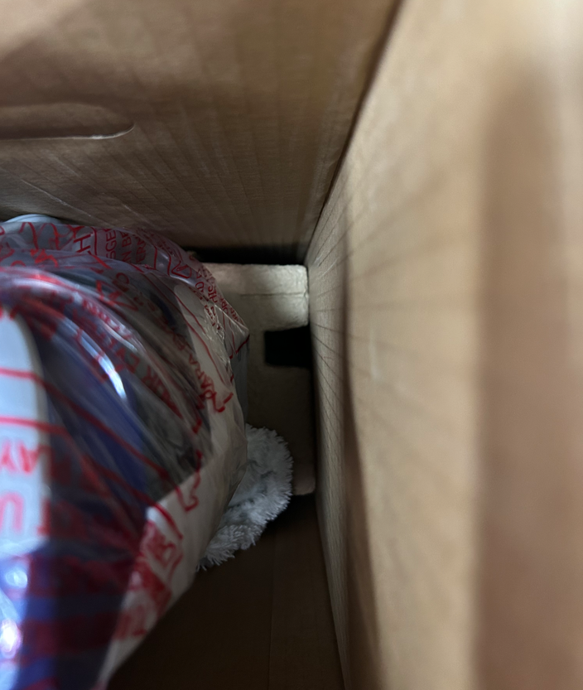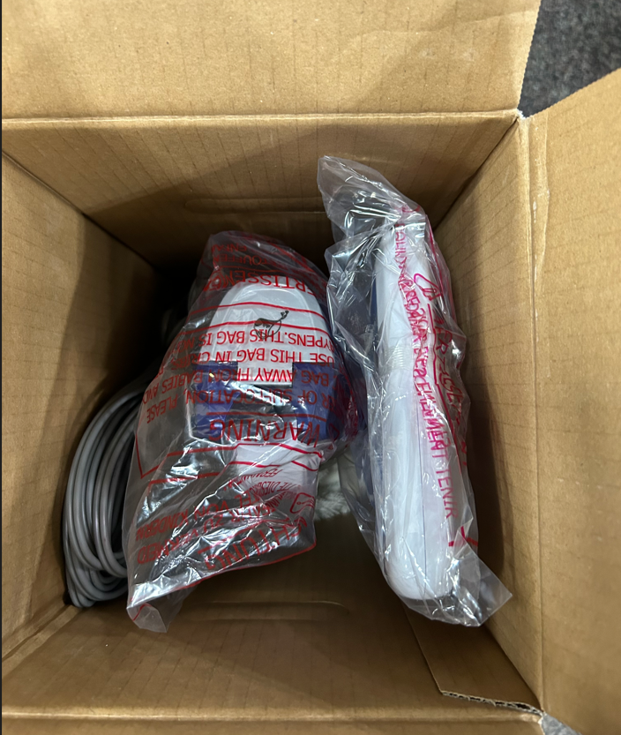

- Place the top corrugate insert back into the top of the carton.
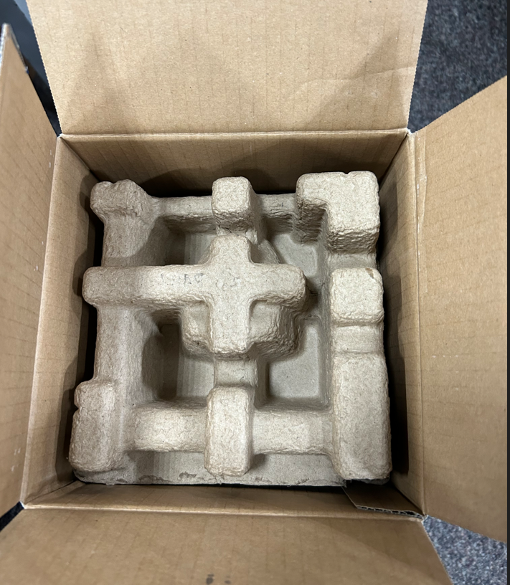

- Close the top flaps of the carton and tape them shut again.
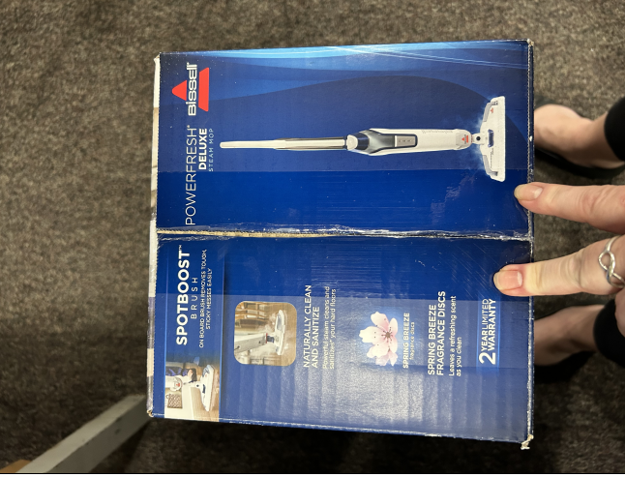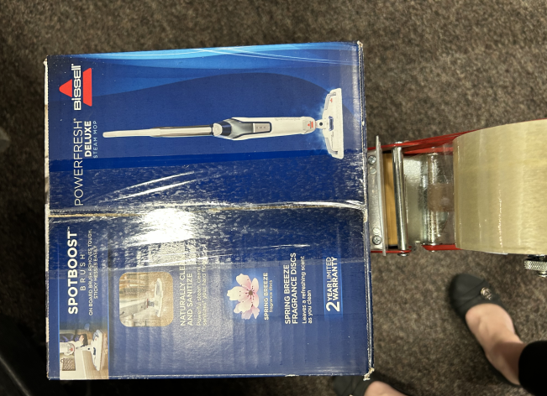

- Locate the back panel of the carton and place 3361F UPC/Model # sticker over current UPC/Model # as pictured below:
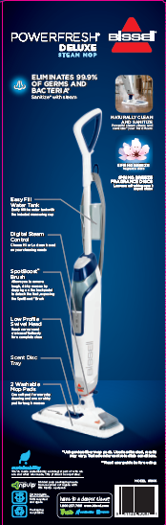

- Repalletize per 3361F pallet instructions on supplier site.

