Part Number | Description
2846 | Pet Stain Eraser PowerBrush Plus
n/a | Model #/ UPC label- Print at DC

Instructions:

- Obtain a pallet of 2846 Pet Stain Eraser PowerBrush Plus
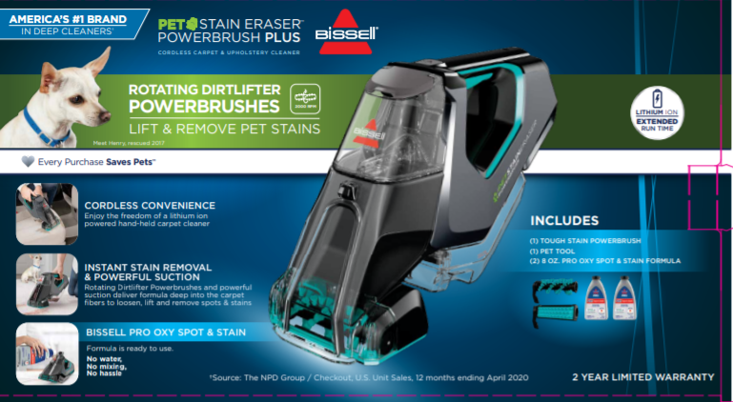

- Find the UPC code on the back of the box, and print off the new UPC (011120254594*) and model # (28378) and label over.
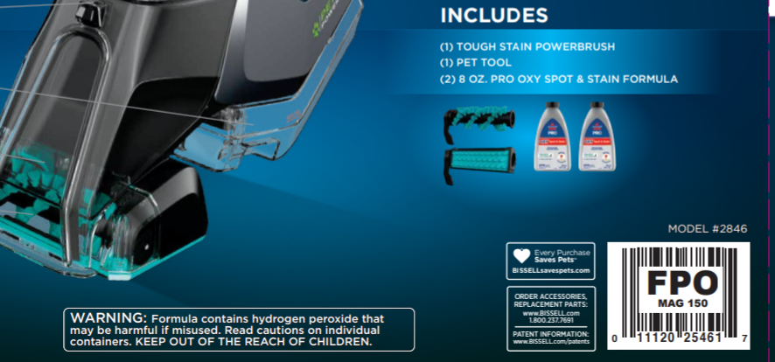

- Repalletize based on the supplier site pallet pattern for model 28378
